**(32) Climate-India**

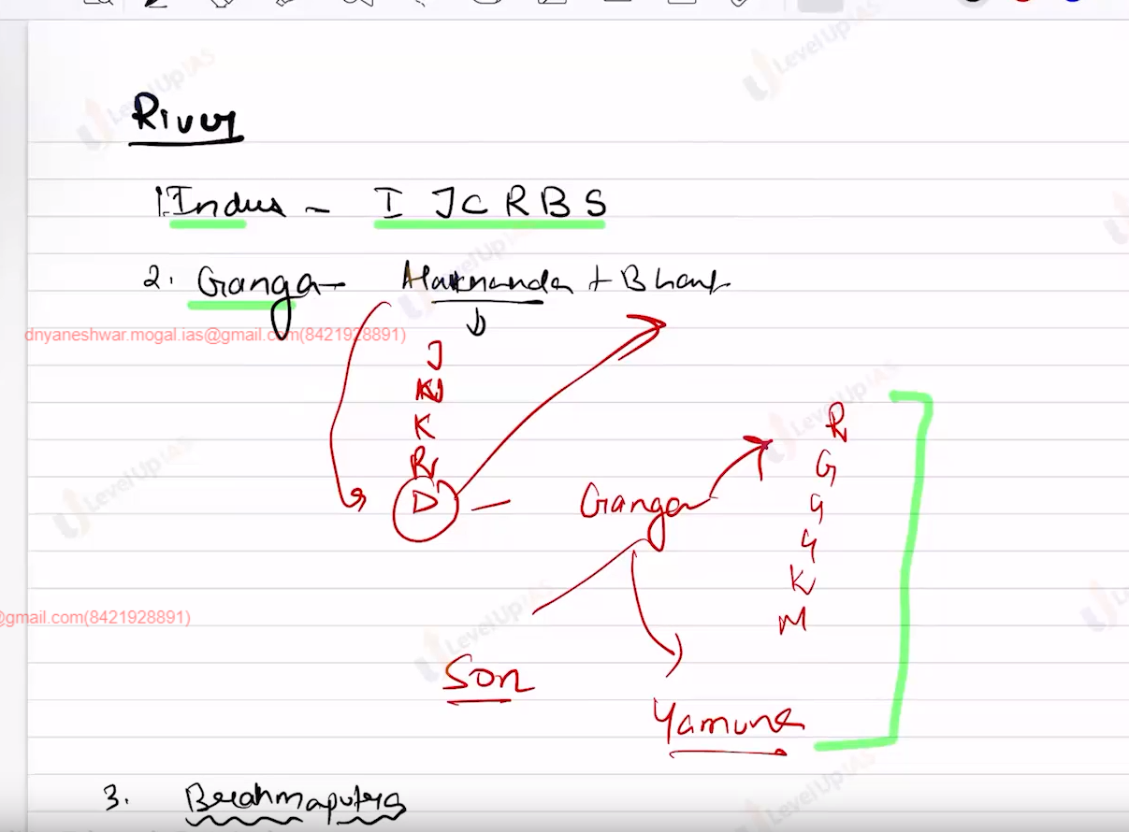

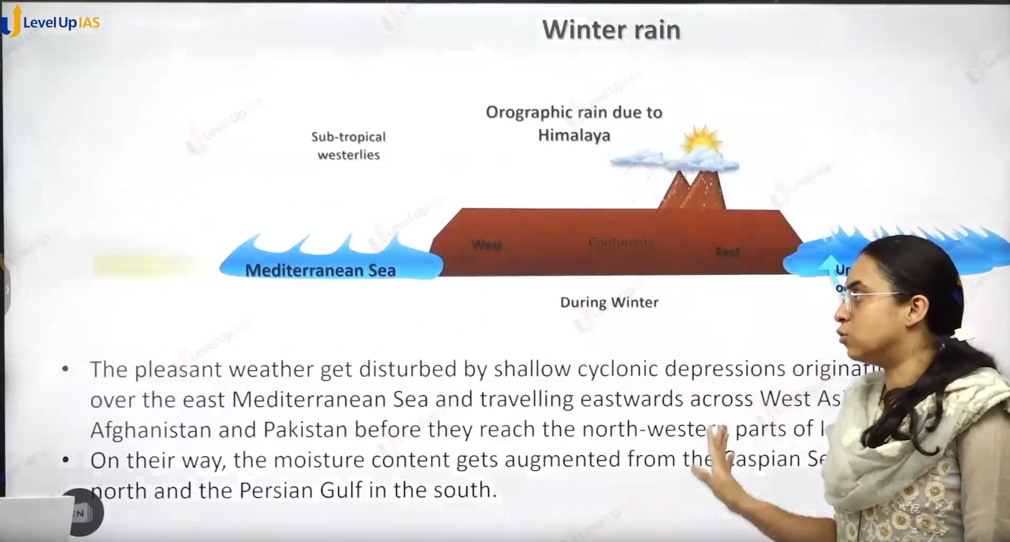

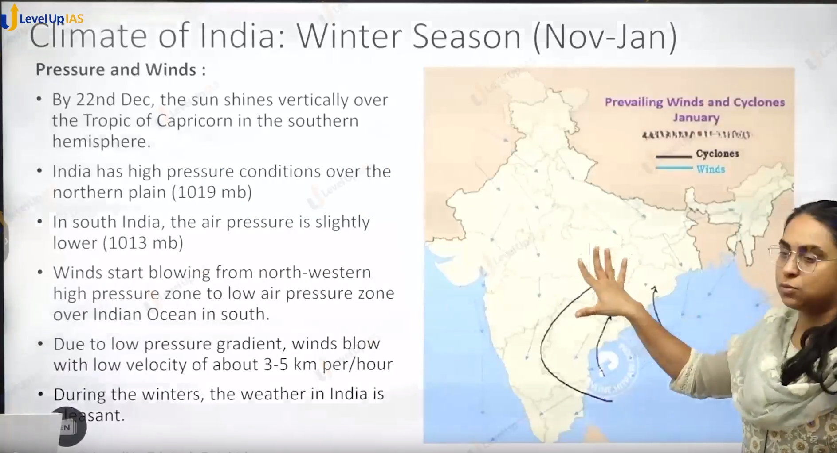

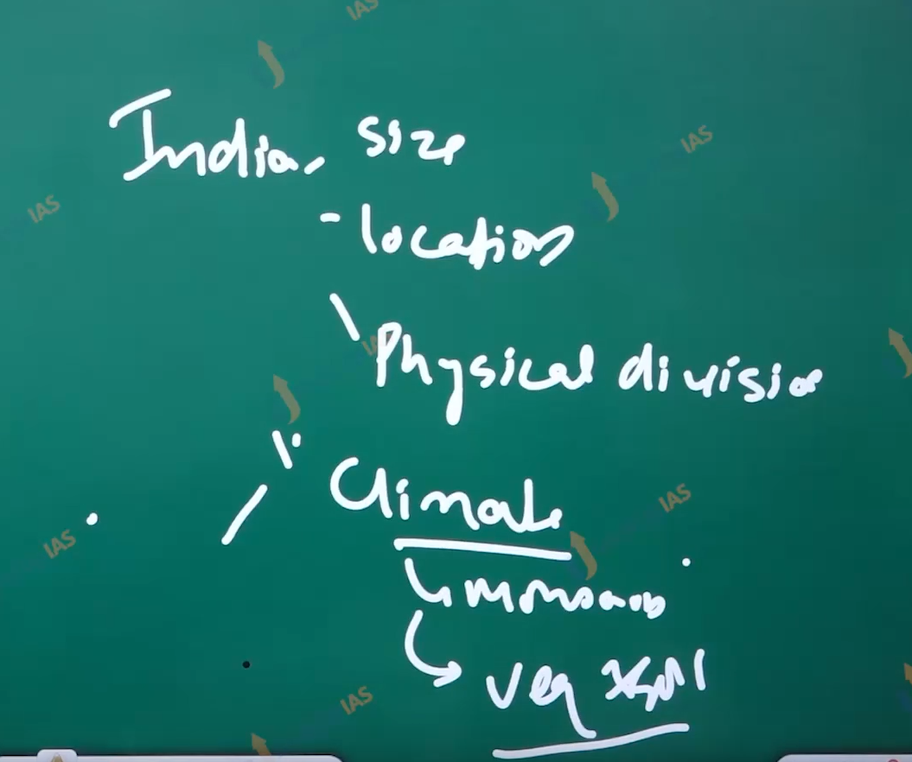

Climate of India:

1. The factors affecting the climate:
   1. Latitude
   2. Continentality
   3. Relief: Himalayas, slope, abrade slope and upback slope.
   4. Upper tropospheric winds:
      1. Tropical easterlies jet stream.
      2. Tropical westerlies Jetstream.
   5. Surface pressure conditions.

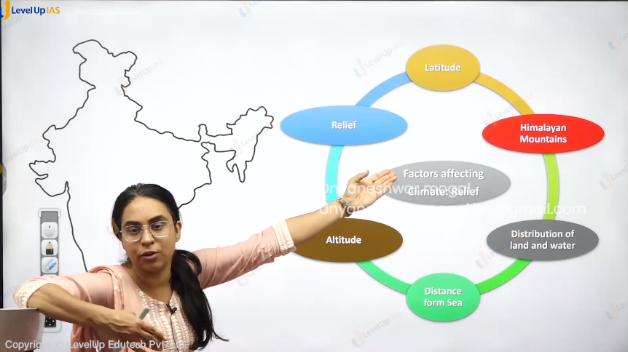

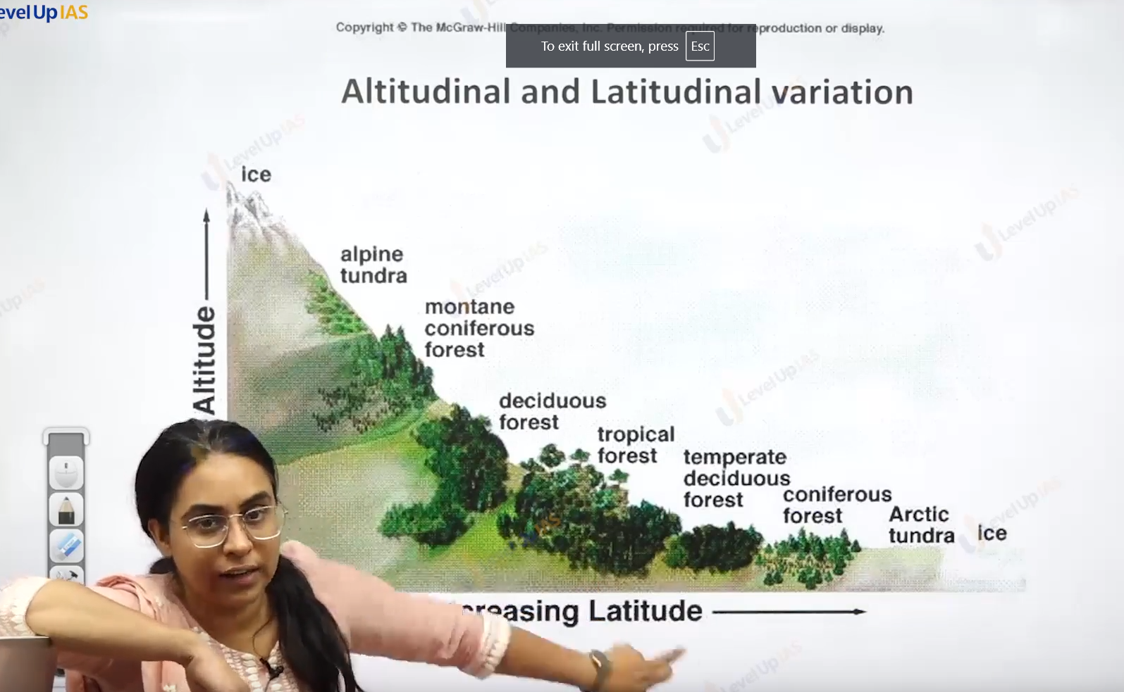

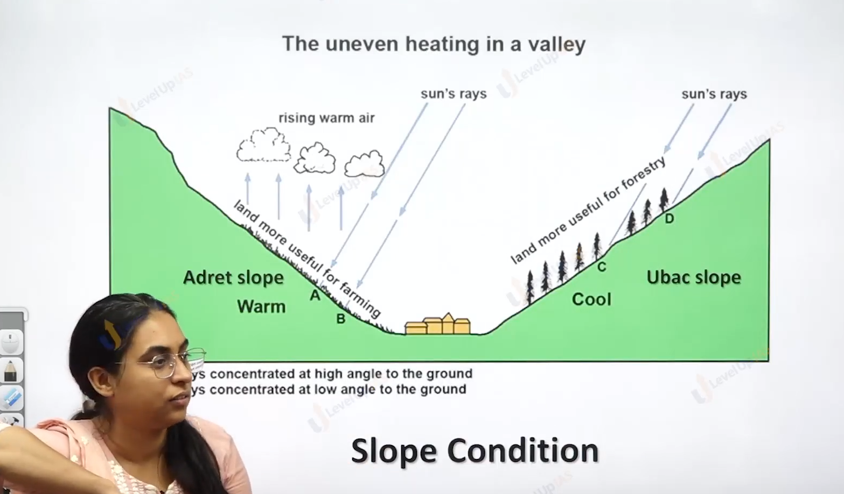

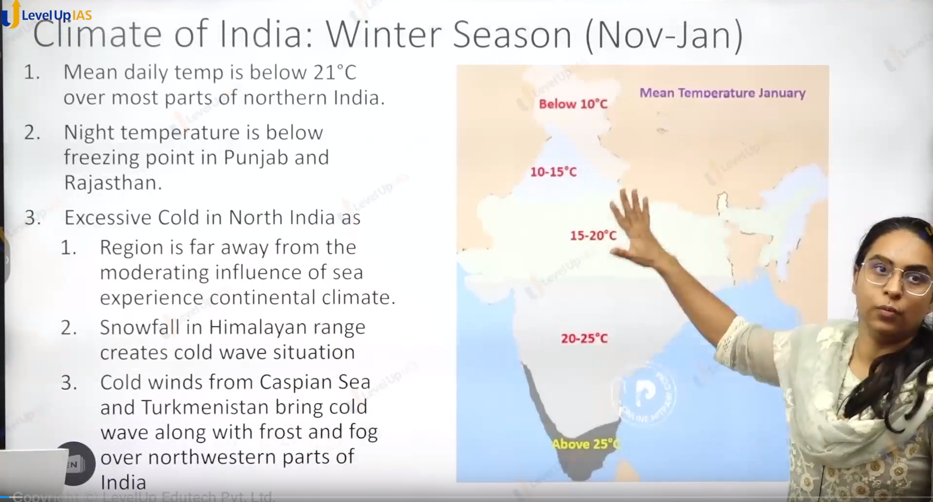

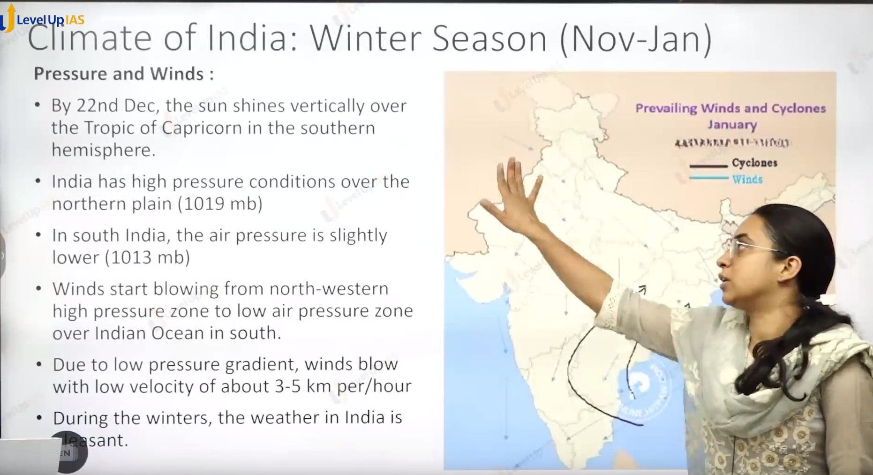

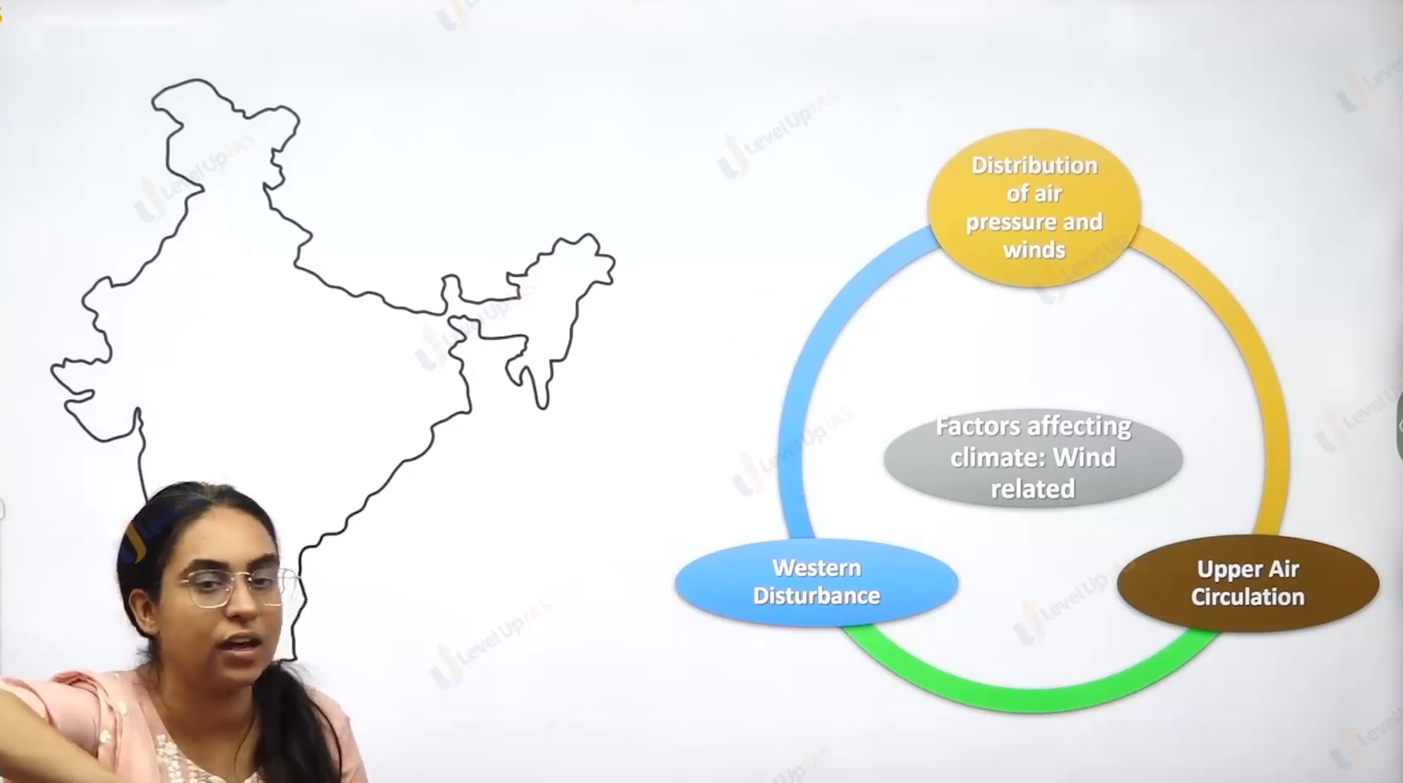 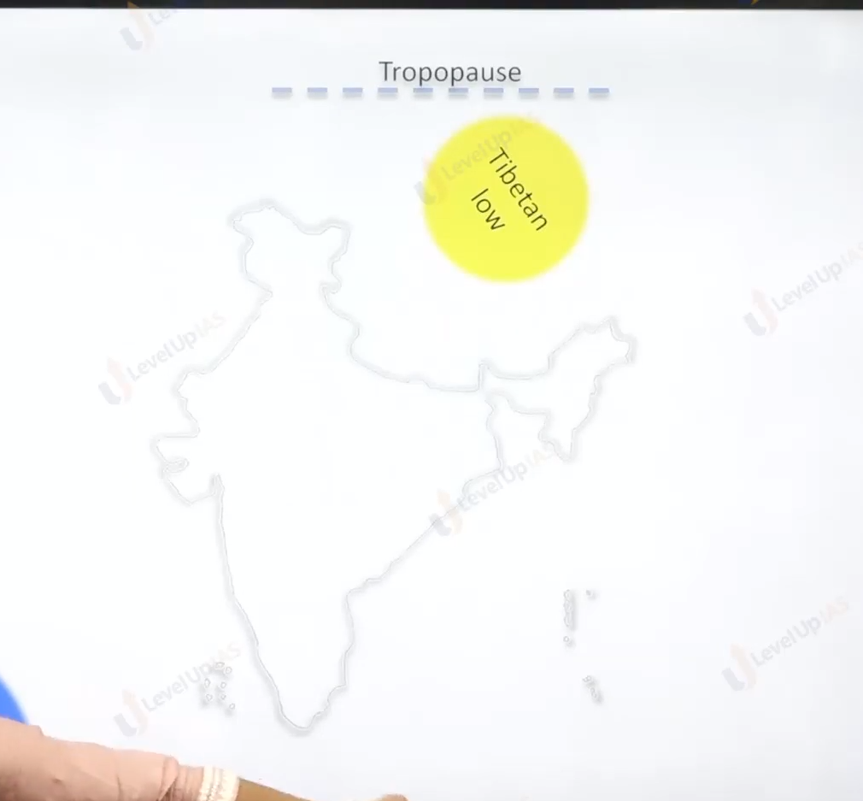

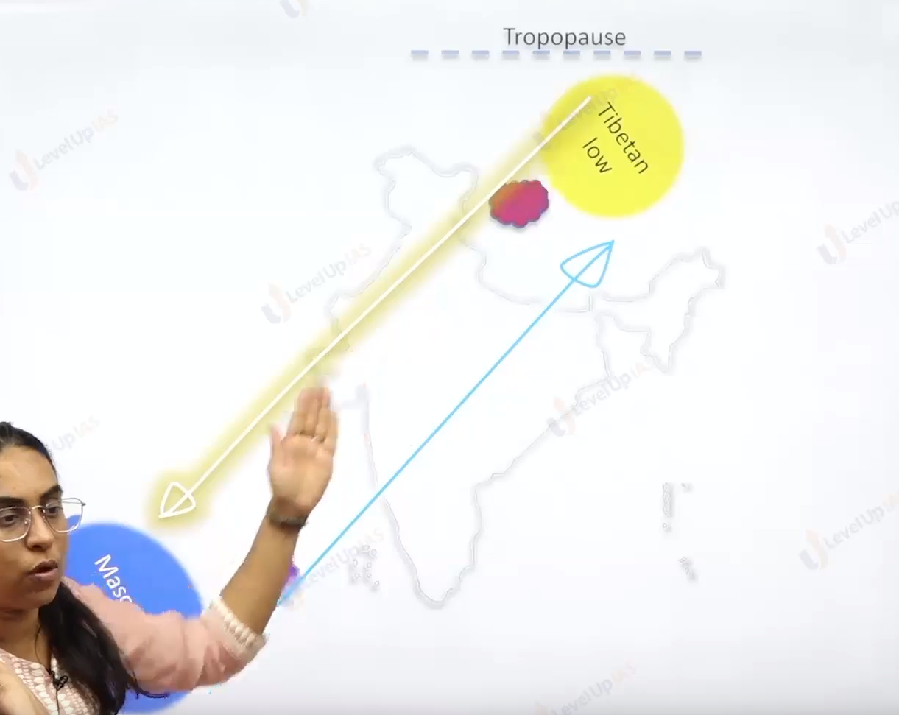

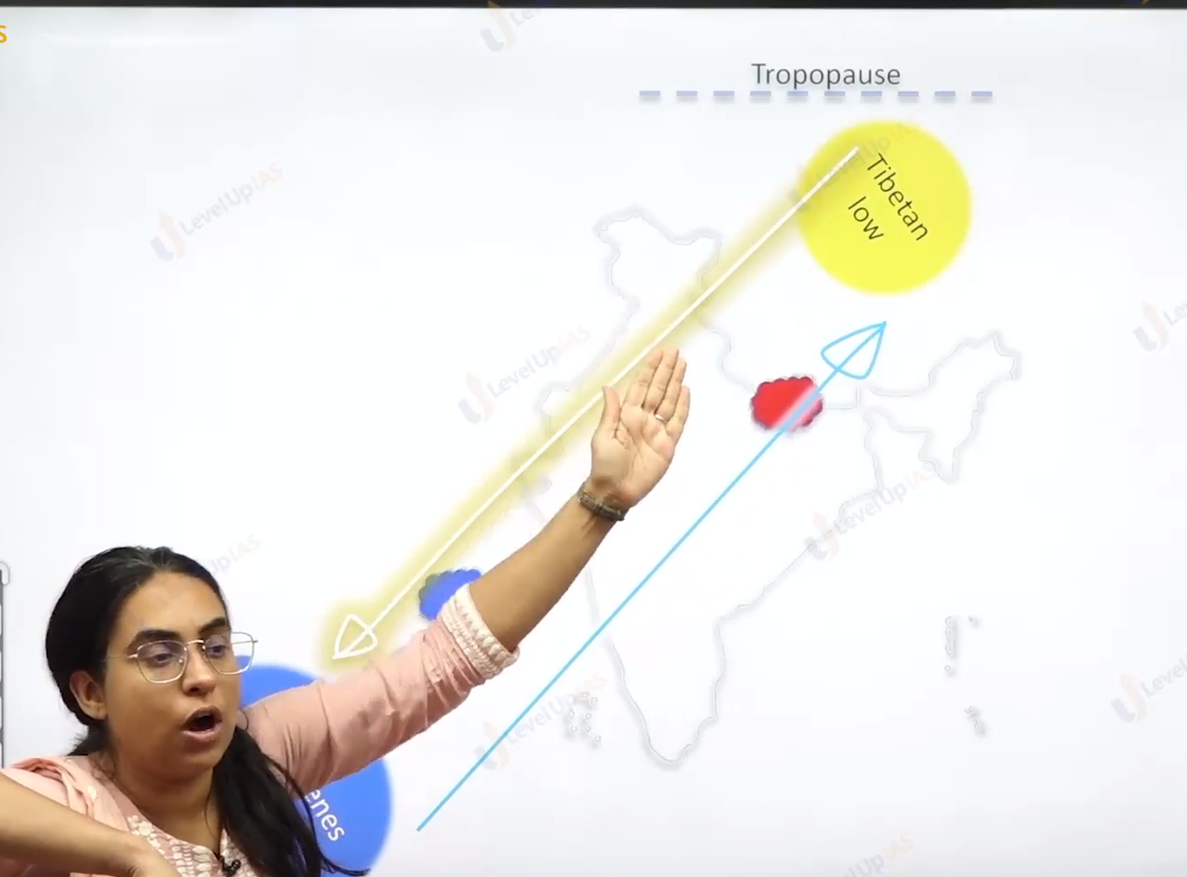

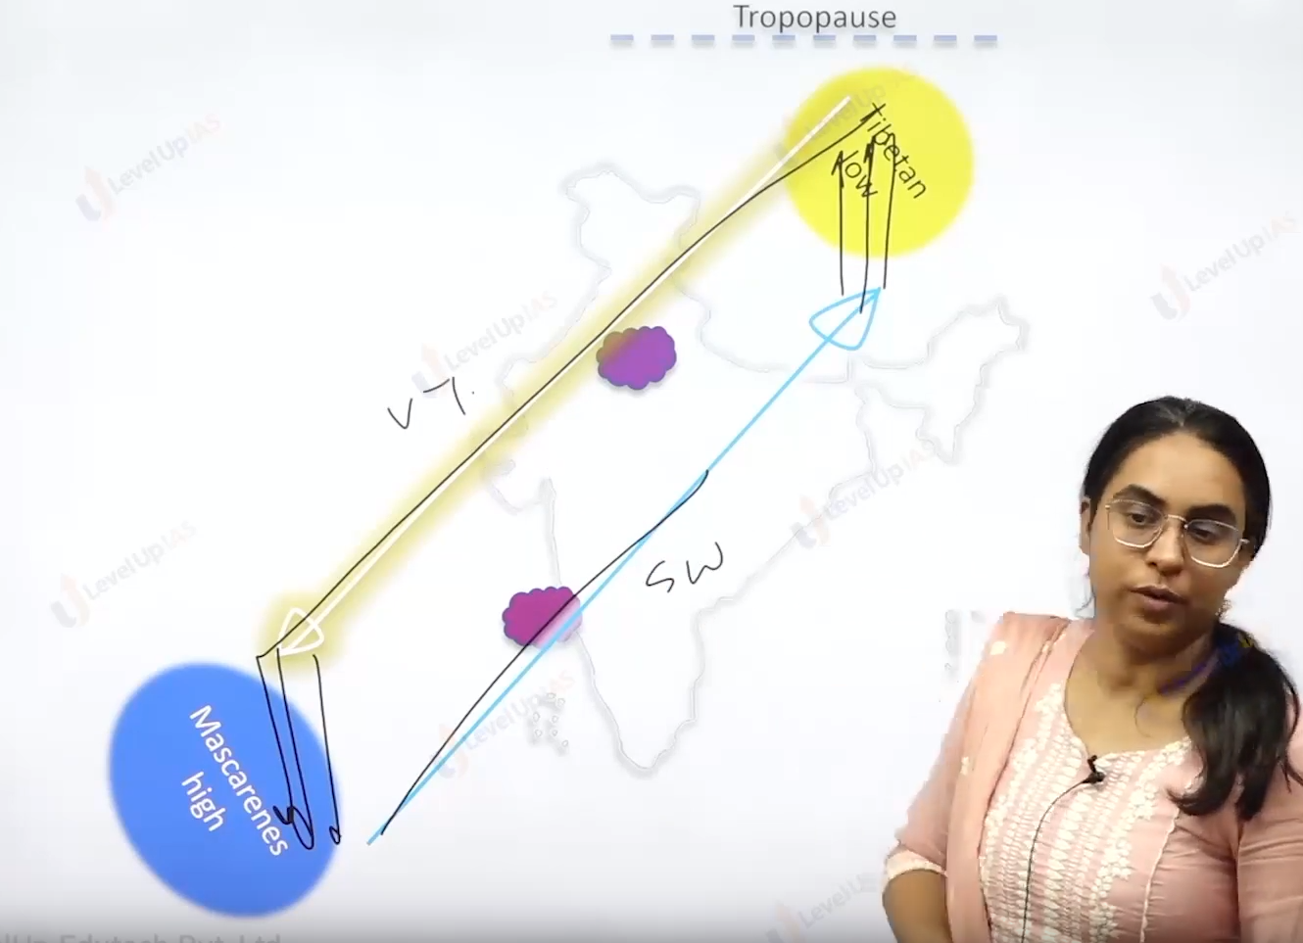

Winter season:

1. The average daily temperature is below 21 degrees Celsius over most part of north India,
2. Night temperatures can be below freezing point in region of Panjab and Rajasthan north Indian is excessively cold.
3. The reasons for excessive cold in the north India are:
   1. The region is away from the moderating influence of sea therefore it experiences the extremes temperature.
   2. Snowfall in the Himalayas creates cold conditions.
   3. Cold winds from the Caspian Sea and Turkmenistan bring cold wave along with frost and fog over northwestern part of India.
   4. Peninsula region of India does not have any well-defined well defined cold weather season. There is hardly any seasonal change in the temperature in the coastal area. because of moderating influence of sea.





1. In winter on 22 of December of sun shines vertically on the tropic of Capricorn in the southern hemisphere, North plane they have high pressure conditions while the southern India air pressure is slightly lower therefore the winds start blow from the high-pressure zone (north India) to low pressure zone. Over southern India and Indian ocean.
2. The winds are generally offshore therefore it does not yield rainfall however some places that receive rainfall in the India are northwest India due to western disturbances (moisture is brought by subtropical westerlies Jetstream from the temperate cyclone that originates over Mediterranean Sea.
3. Central part of India and northern parts of peninsula
4. Arunachal Pradesh and Assam in the northeastern India.
5. The tamandu coast: the rain on the Coromandel coast because of surface winds That is northeast monsoon winds surface winds.
6. Northeast monsoon winds are pick up the moisture while blowing over the bay of Bengal and cause rainfall in tamandu and Andra coast due to onshore winds.
7. Generally, the winter season is from the December to march.

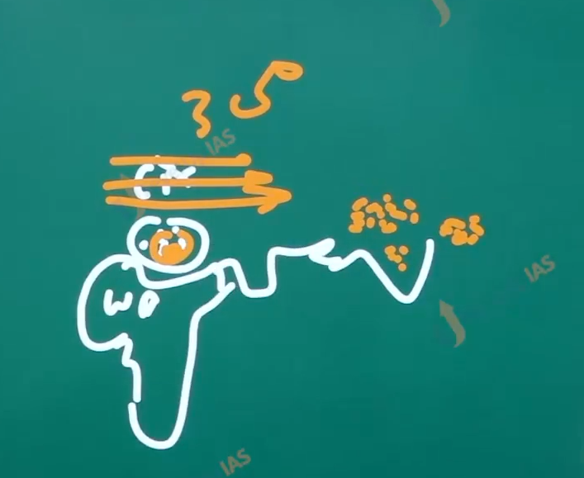

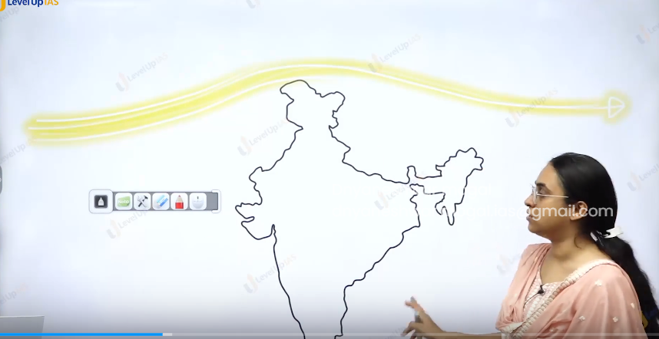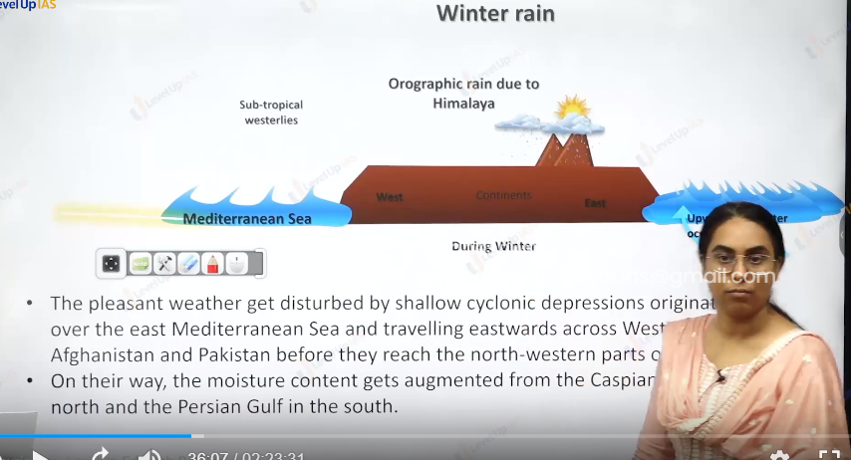

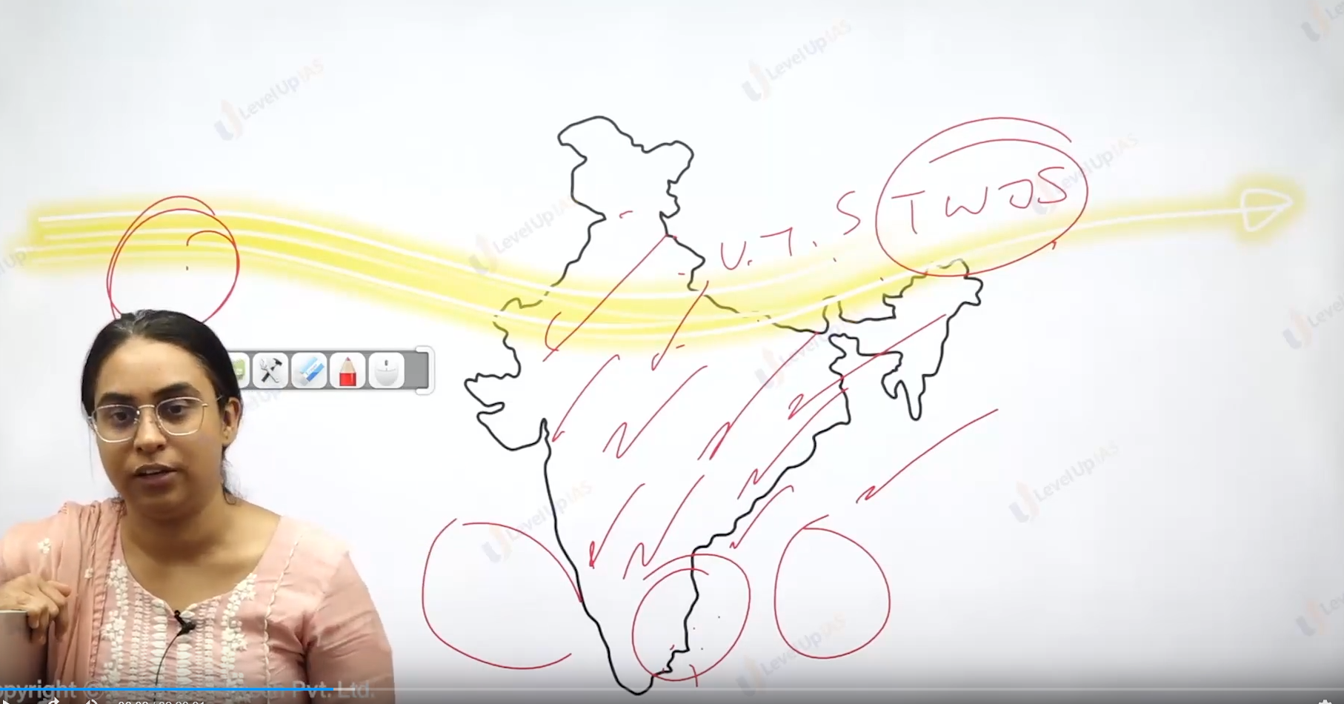

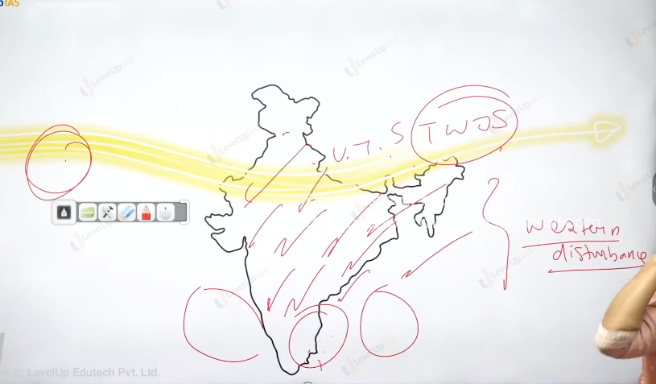

Summer Season:

1. Generally, the summer season is in India is form the 15 March to 15 of June.
2. Due to apparent shift of the sun from Capricorn to equator (23 March) to tropic of cancer 21st June.
3. The temperature starts raising in the northern India the temperature rise as far as 40 degrees Celsius however the hot weather season is mild in the south India due to moderating effect of Ocean. South temperature (25 to 27).
4. The excessive heat in the summer creates low pressure zone from thar desert to Chota Nagpur plateau this is called as low-pressure trough.
5. In the summer the dust storm Is common in the Panjab, Haryana, UP, Rajasthan. this dust storm can yield mild/minute rain can respite from the summer heat.
6. Dry hot and local winds they blow in the afternoon over the majority of India called as Loo.

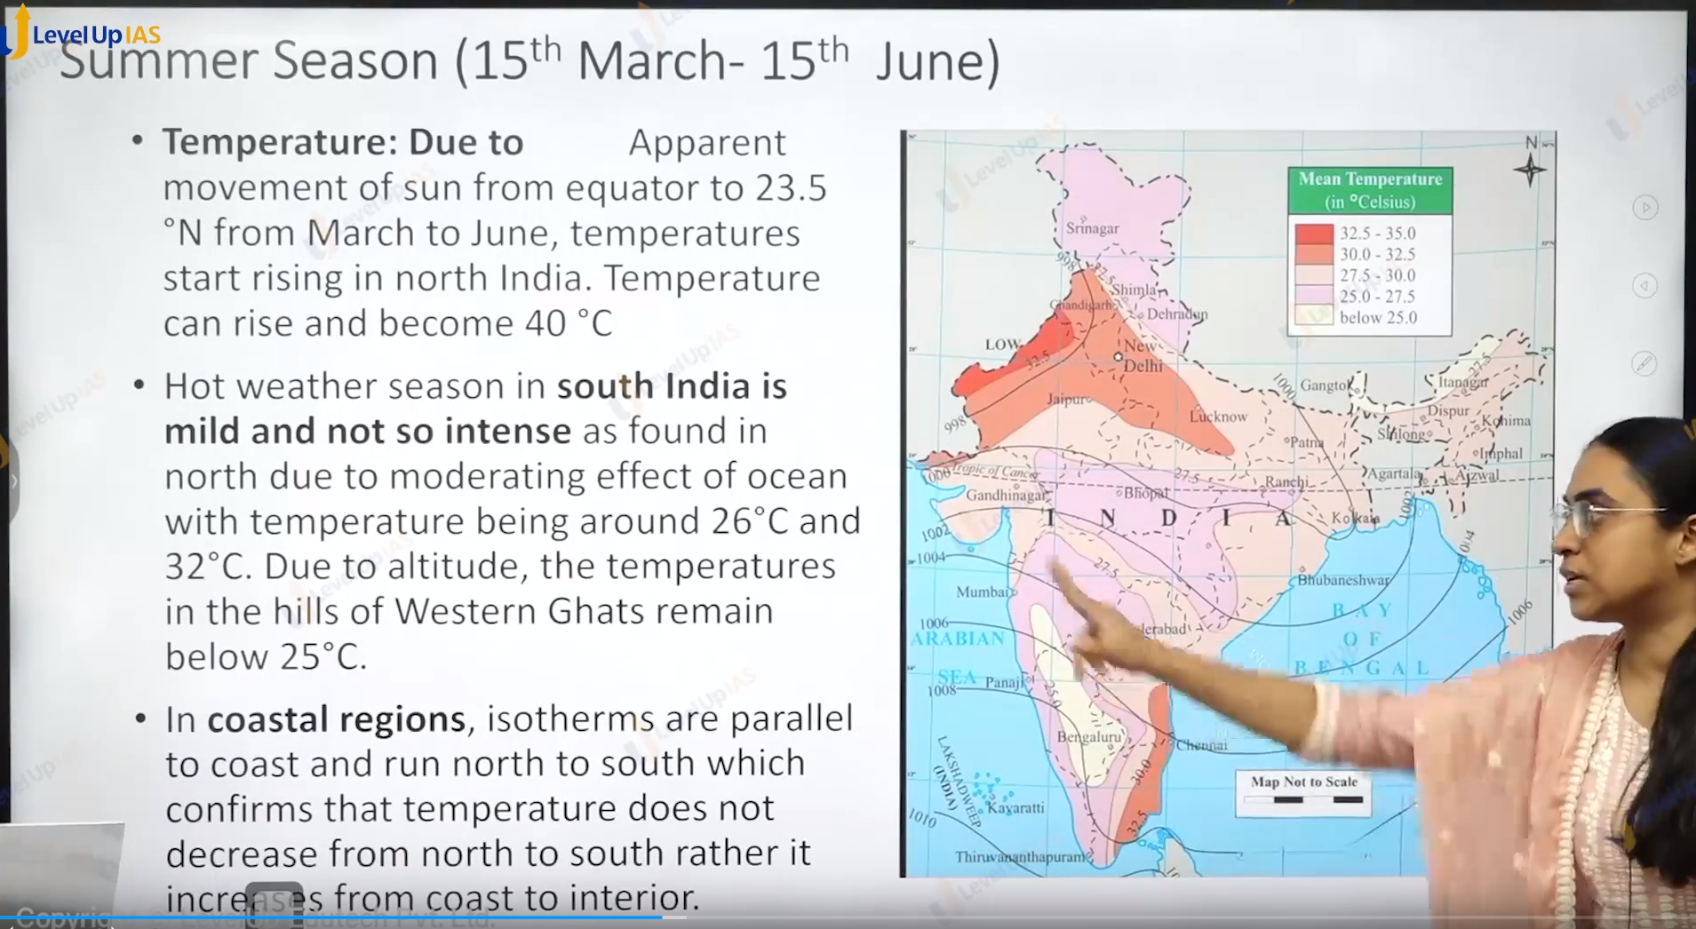

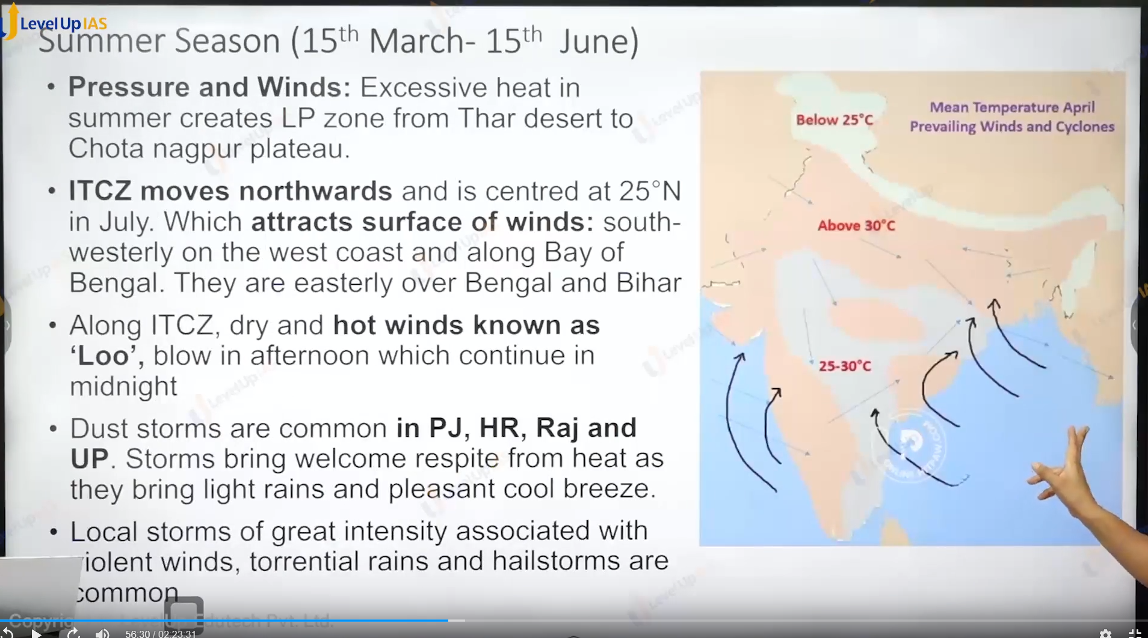

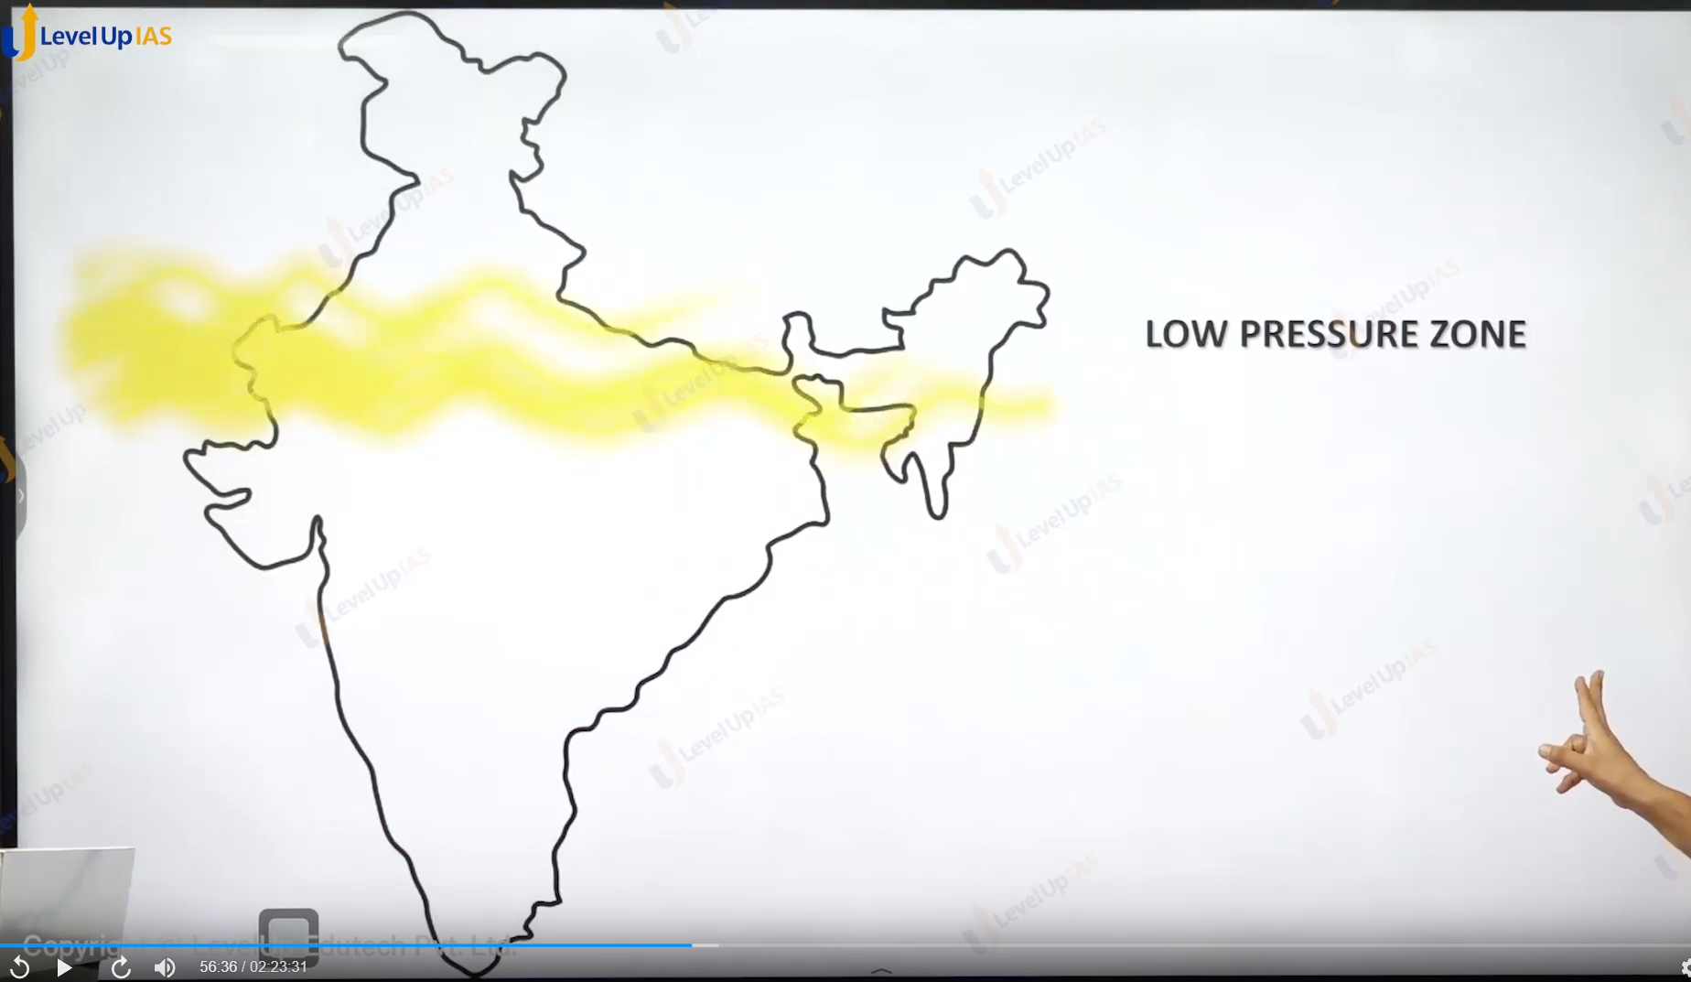

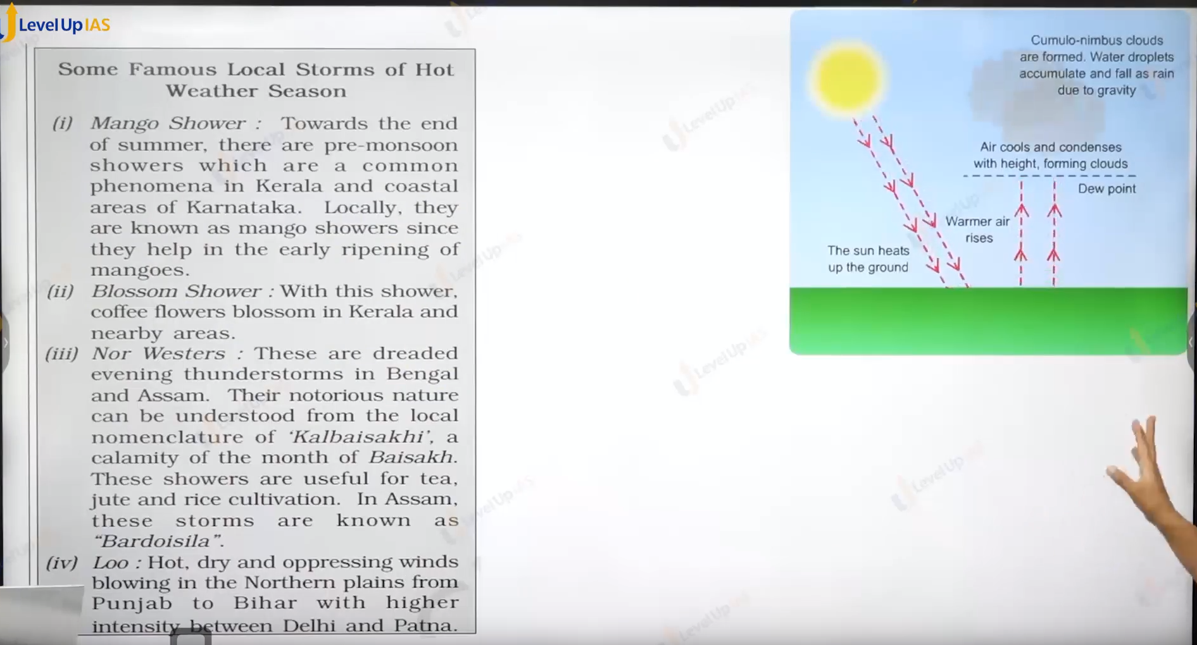

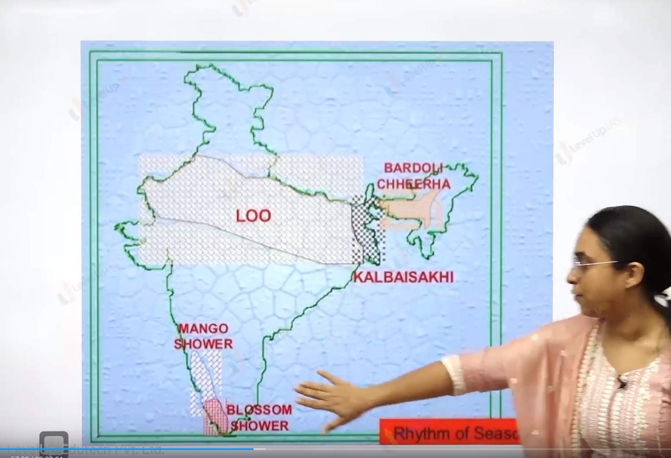

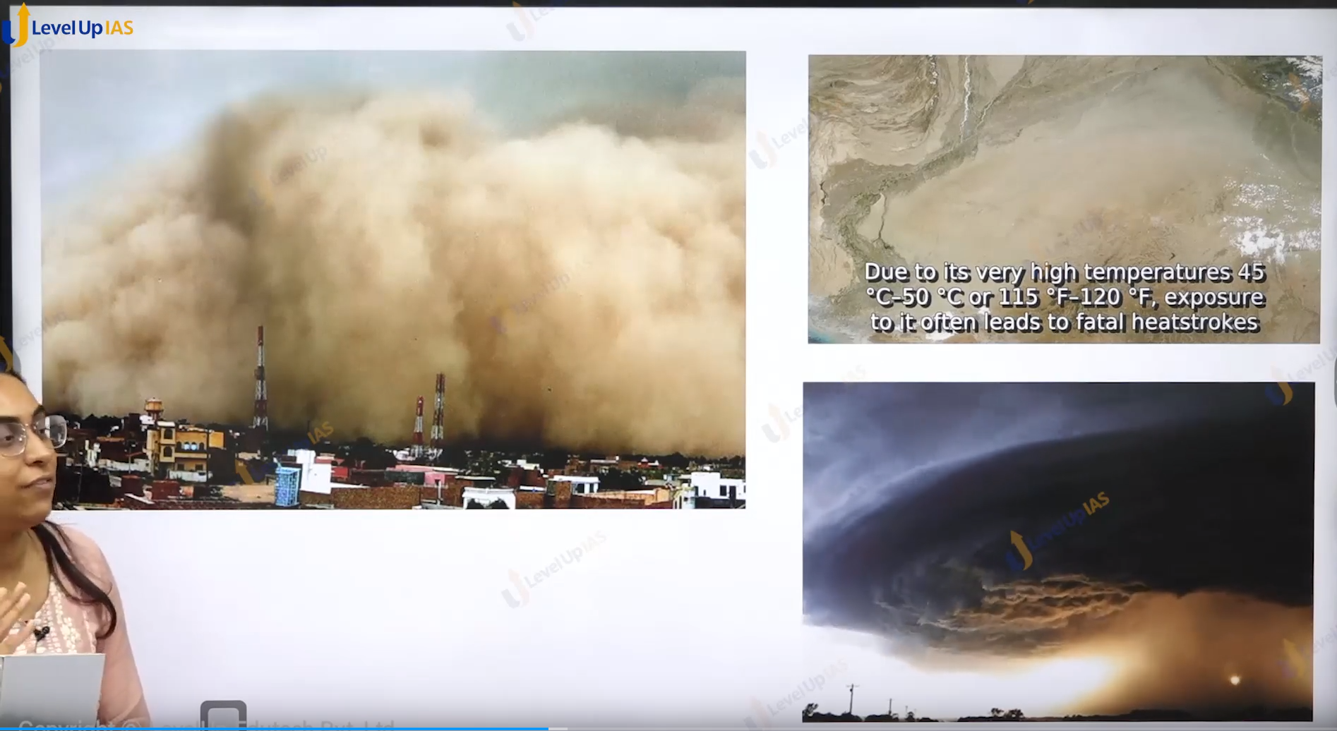

1. There is very strong convectional rainfalls, they are know by different local names such as mango shower in Kerala and Karnataka, blossom shower in Kerala and nearby area. blossom shower helps in coffee plantations. Nor wester they are thunderstorms in Bengal and Assam. They are also locally called “kal Besakhi”.
2. They are important for the cultivation of rice, jute and tea.
3. In Assam this storm they are called “bardoi cella”.

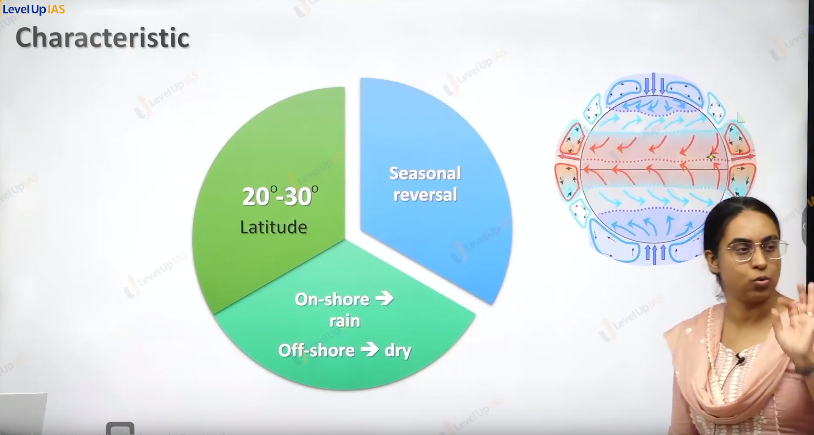

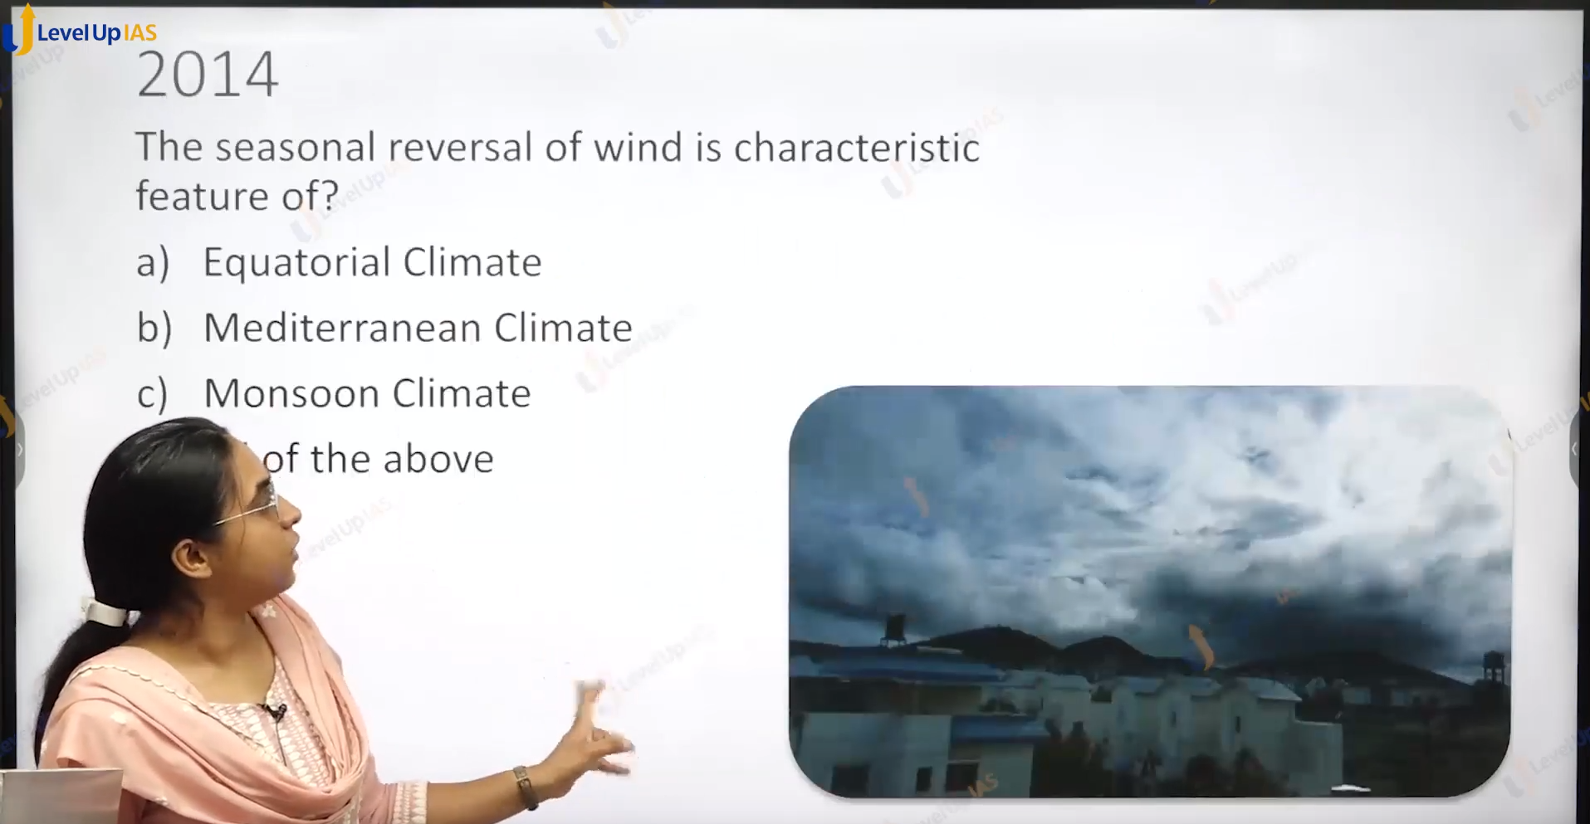

And : C there is no reversal in mediterranean sea, and equatorial.

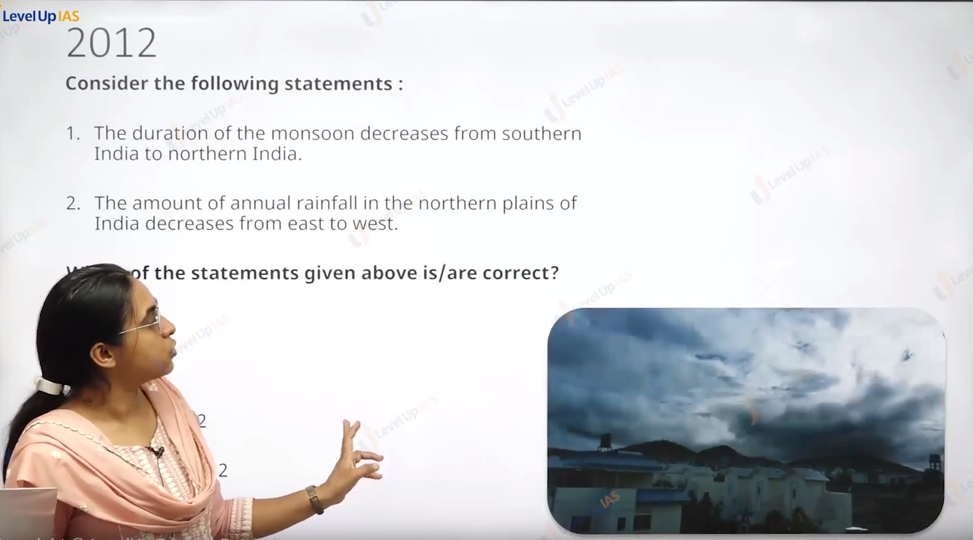

Answer is C:

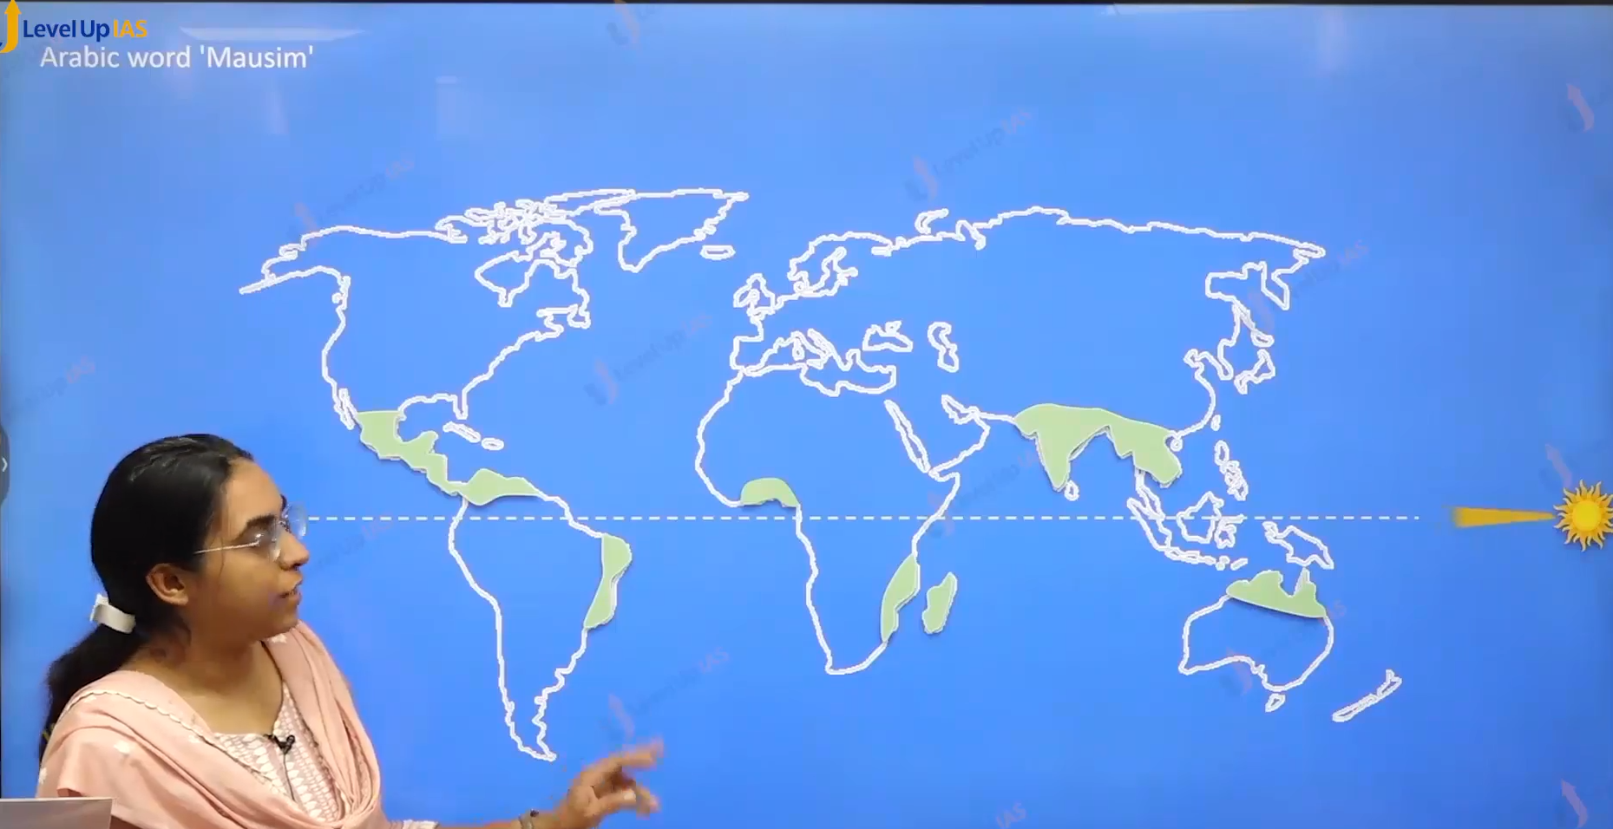

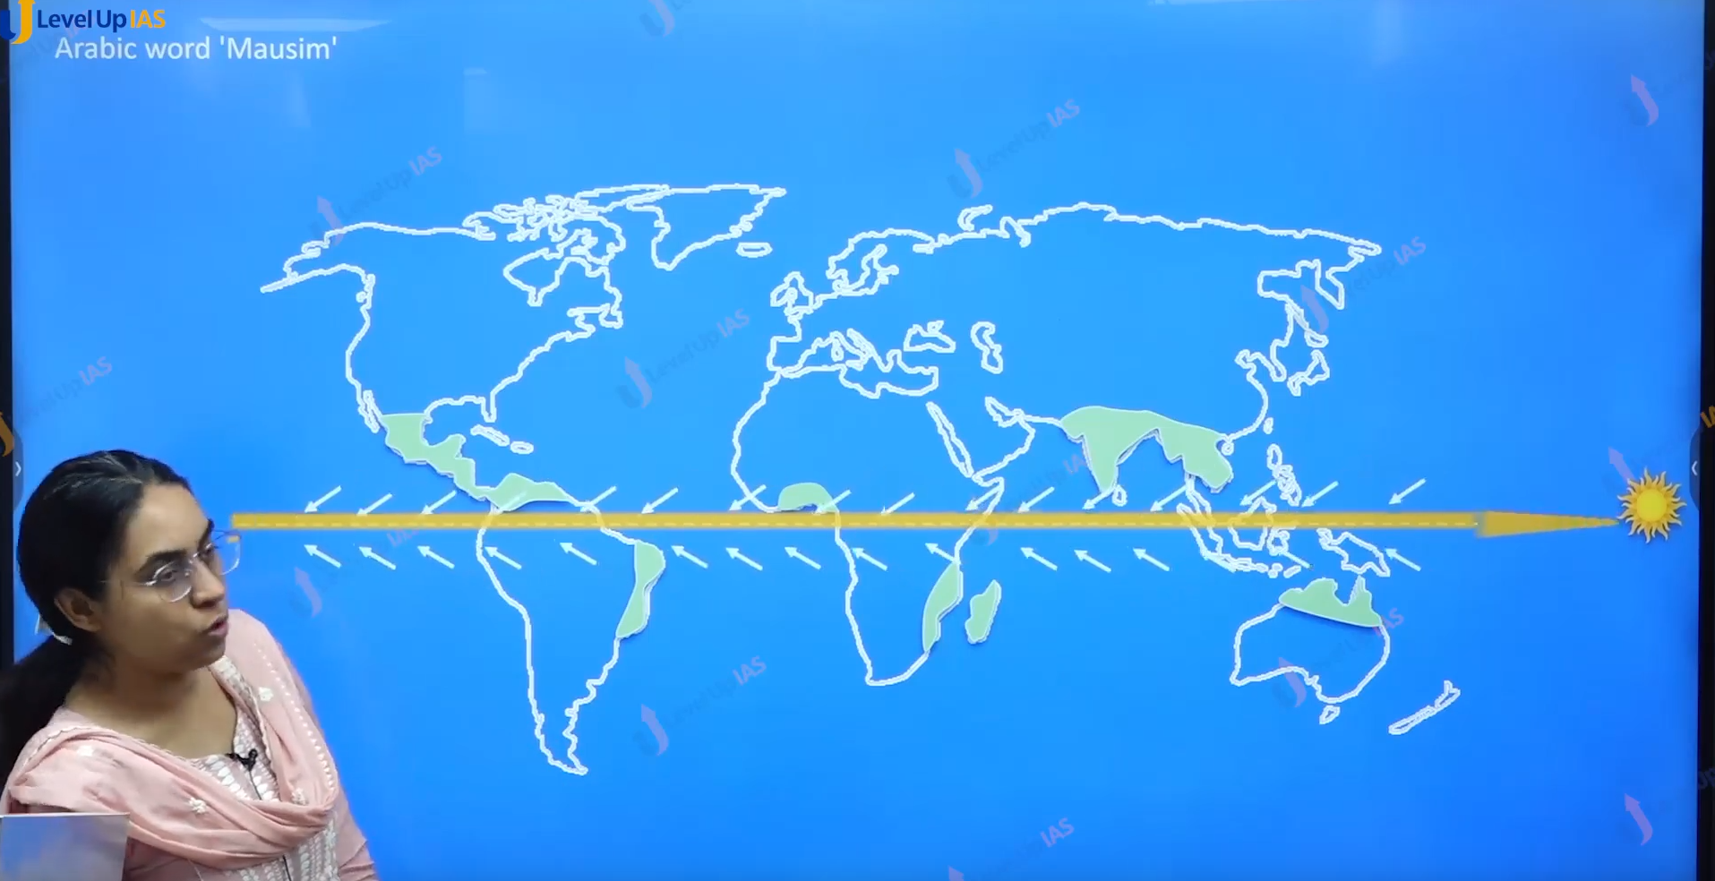

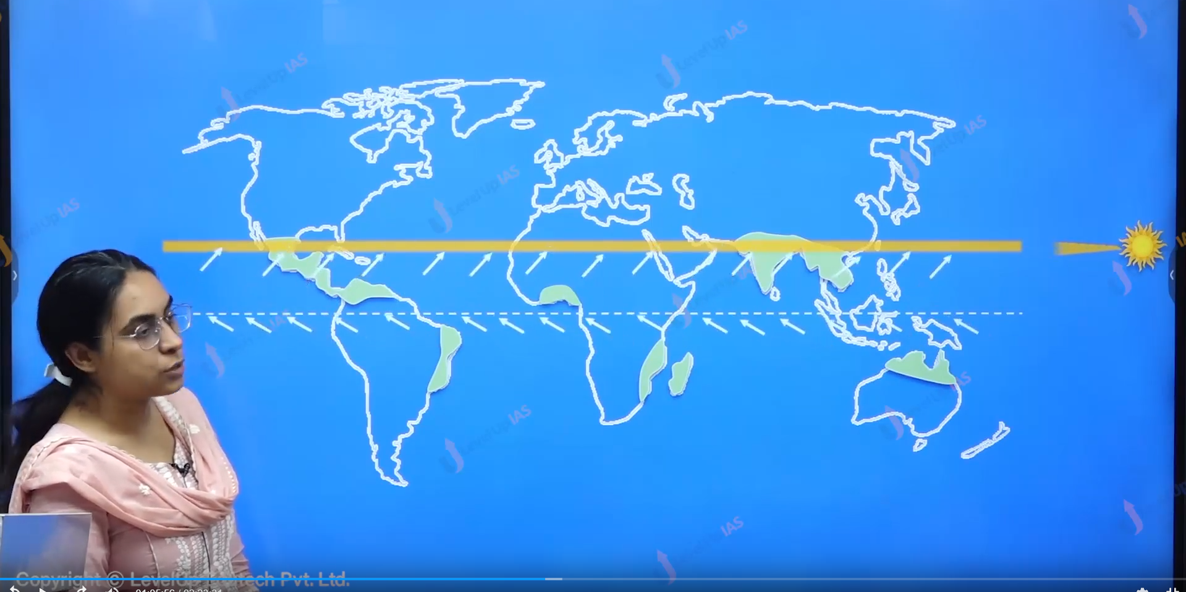

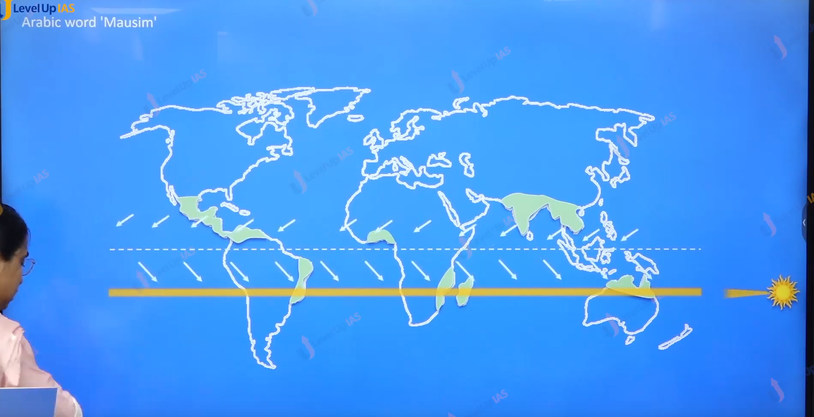

Initial face of monsoon:

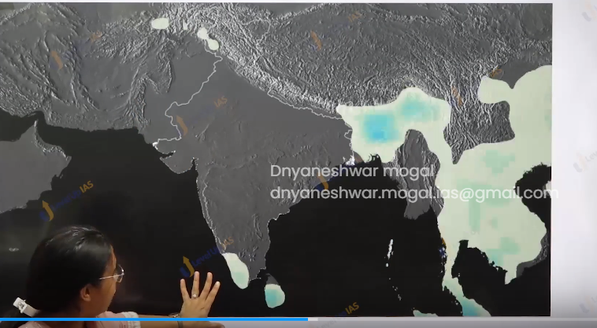

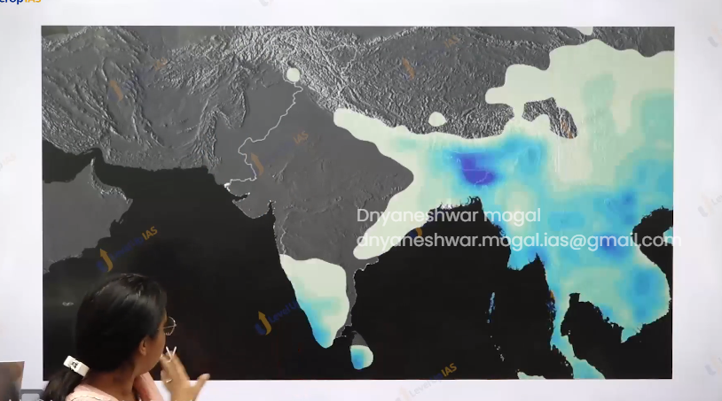

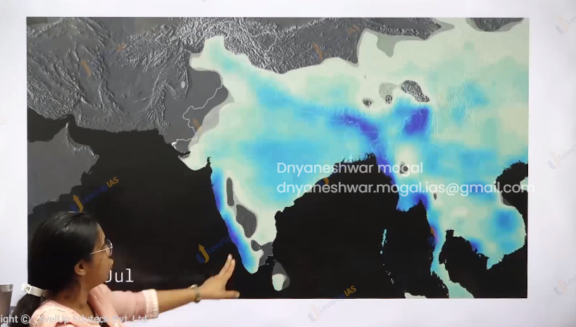

It reaches the north India and it will return back

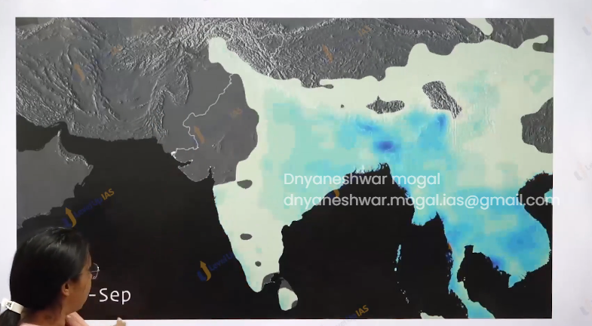

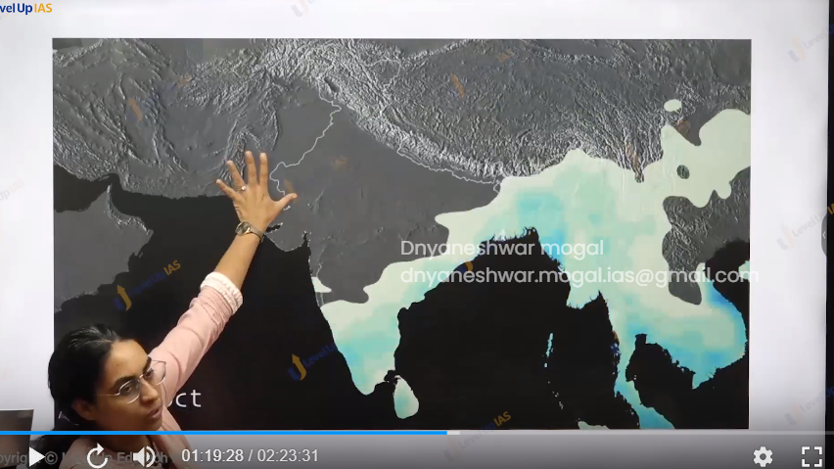

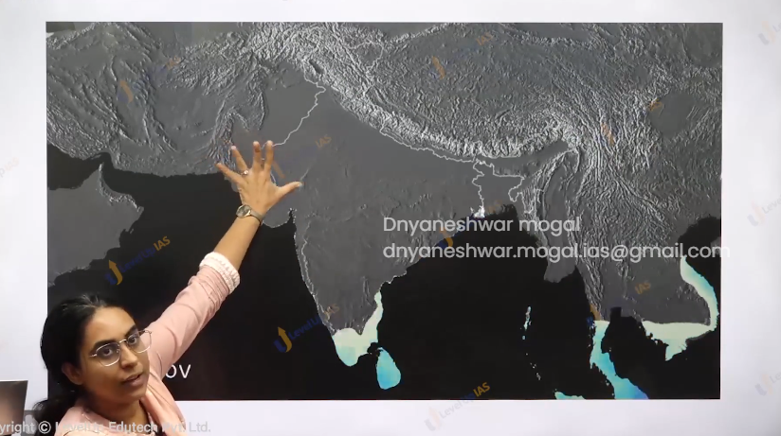

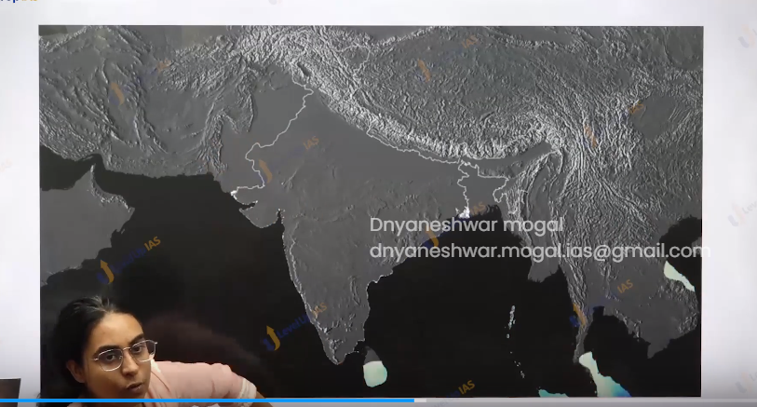

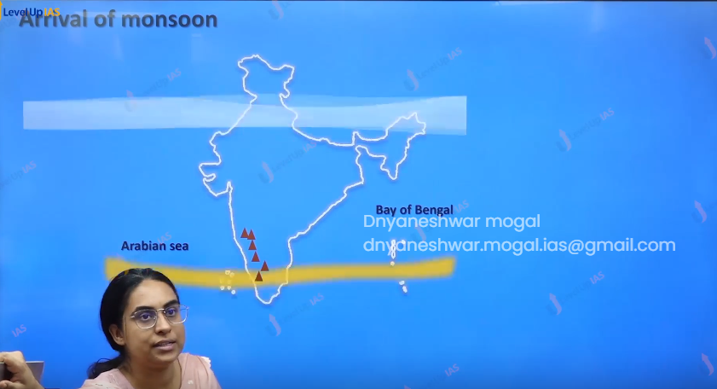



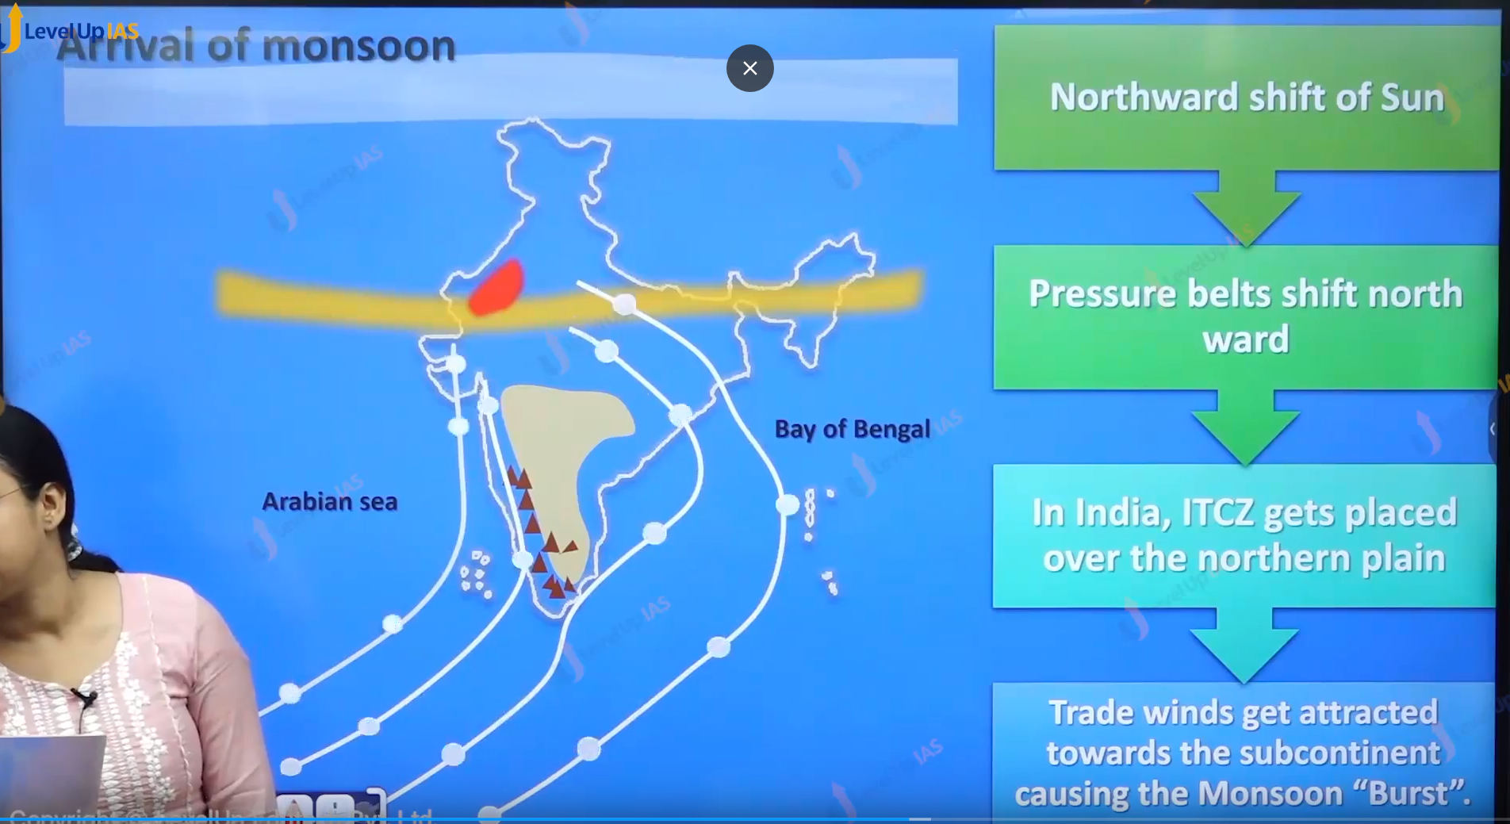

Monsoon Climate of India:

1. Monsoon refers to seasonal reversal of winds it is feature of 20 30 north latitude and south latitude.
2. Monsoon winds bring rainfall conditions when it is on the Onshore And it bring dry conditions.
3. The reversal is perfect for Indian subcontinent.

Arrival of Monsoon:

1. Monsoon winds in India are winds blow from Mascarene high pressure to Tibetan low pressure.
2. Therefore 2 important parameter that determines the intensity of monsoon are
   1. Mascarene high pressure
   2. Tibetan low pressure.
3. Monsoon arrives in India due to northwards shift of sun and the northward shift of ITCZ (ITCZ gets places around north plane) and the northward shift of (sub-tropical westerlies Jetstream) should be situated north of Tibet so that low pressure at the Tibet is strengthen.
4. The trade winds southeast from the massacre turn right after crossing the equator. And gets attacked towards the subcontinent causing the bust of monsoon.
5. The Monsoon winds are not simple land breeze, sea breeze and simplify the surface winds but are influenced by subtropical westerlies jet Stream along with other upper air circulation.

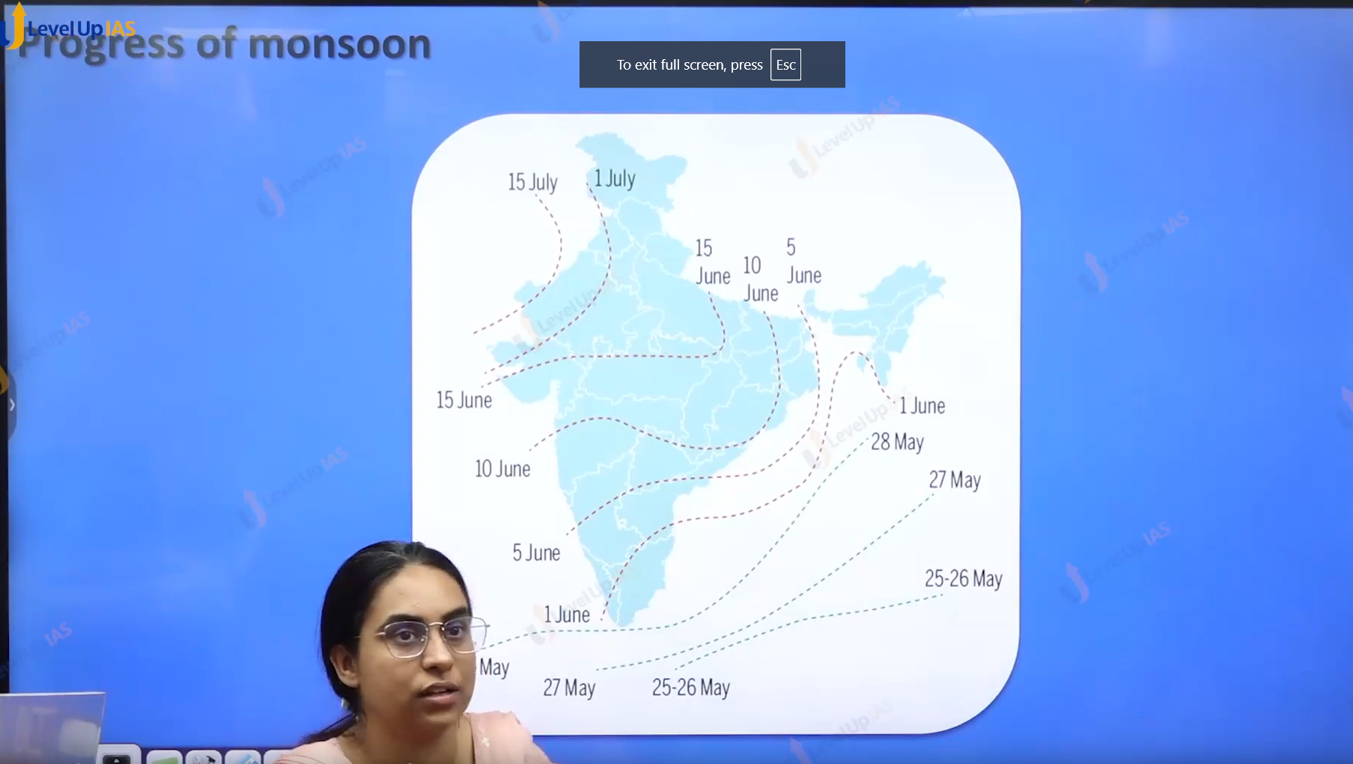





Progress of Monsoon:



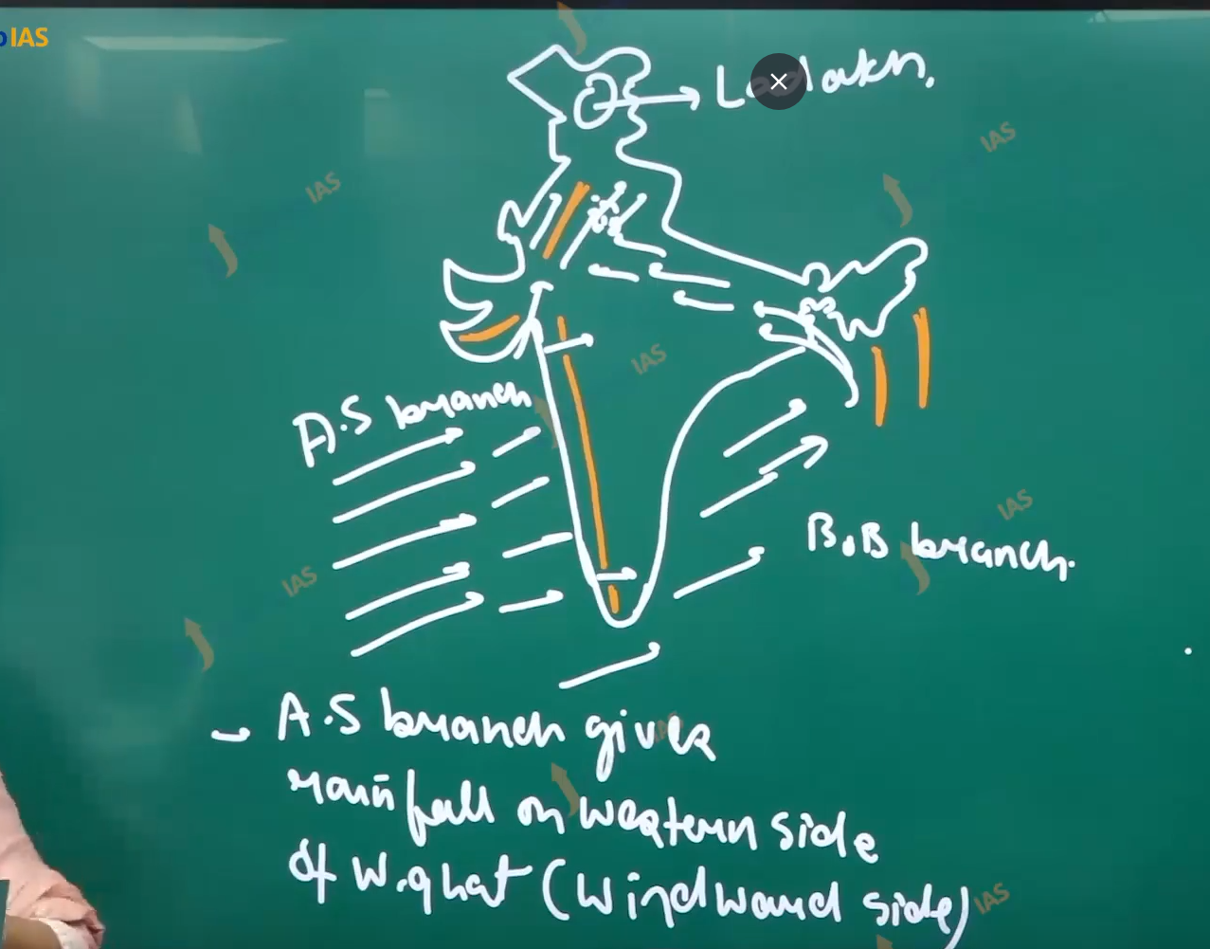

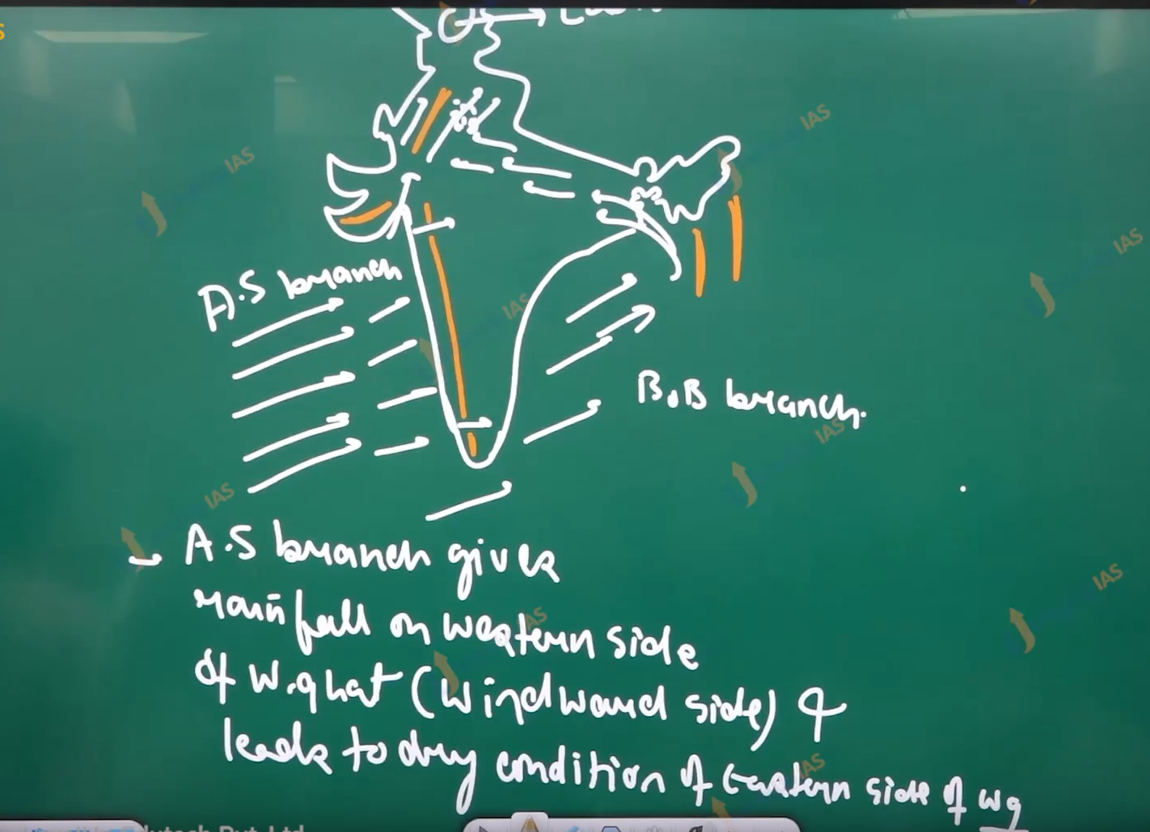

1. Arabian sea branch gives rainfall on the western side of western ghat. (windward side) leads to dry condition in eastern side of western ghat.
2. Arabian sea branch enters the India Peninsula via 3 gaps Narmada-Tapi gap, Sabarmati Mahi gap, and Shikotan gap in Kerala.
3. The Monsoon winds that enter India via Sabarmati Mahi bap blow parallel to Aravali hills range. And therefore, leads to dry conditions.
4. It gives rainfall to the foothills of Aravalli Mountain range.
5. The winds that pass-through Narmada -Tapi valley gap gives rainfall at the foothills of Aramaneak plateau.
6. Way of Bengal branch does not turn effectively towards India peninsula. To give rainfall therefore interior of peninsular plateau is dry (leaved side of western ghat and does not even receive the rain from Bay of Bengal branch.
7. Ex. Telangana, Marathwada.
8. The way of Bengal branch gets defected by the Arakan Yoma and page Yoma towards the peninsular plateau Meghalaya plateau received the full the intensity of way of Bengal branch therefore it one of the wettest places of earth. The region also has heavy rainfall due to the funneling effect.
9. The Bay of Bengal branch defected by the Arakan Yoma Pegu Yoma, enters the north plane and therefore the intensity of rainfall decreases from west Bengal to Bihar to UP.
10. Along the Panjab and Haryana Bay of Bengal branch and Arabian Branch merges to give the rainfalls.

**(33) Climate-India-II**

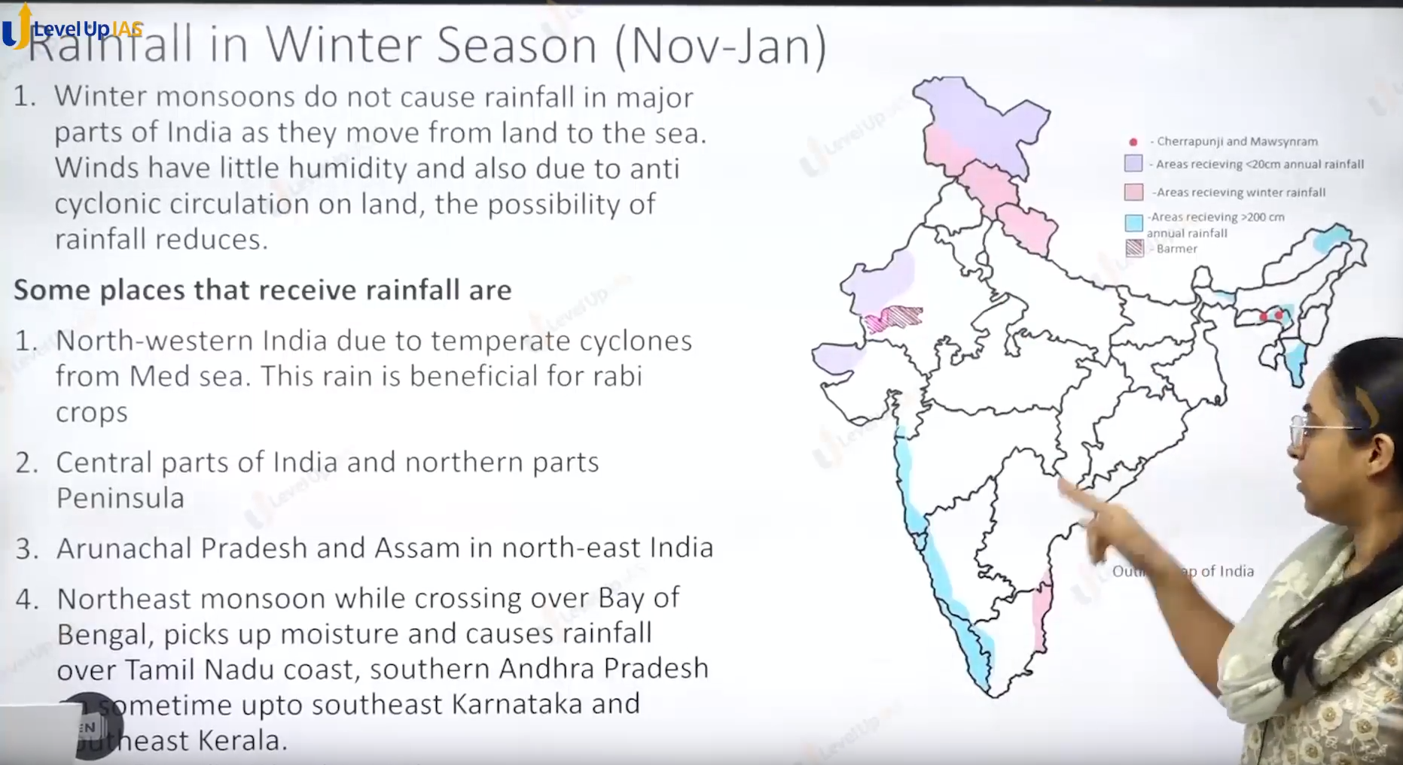

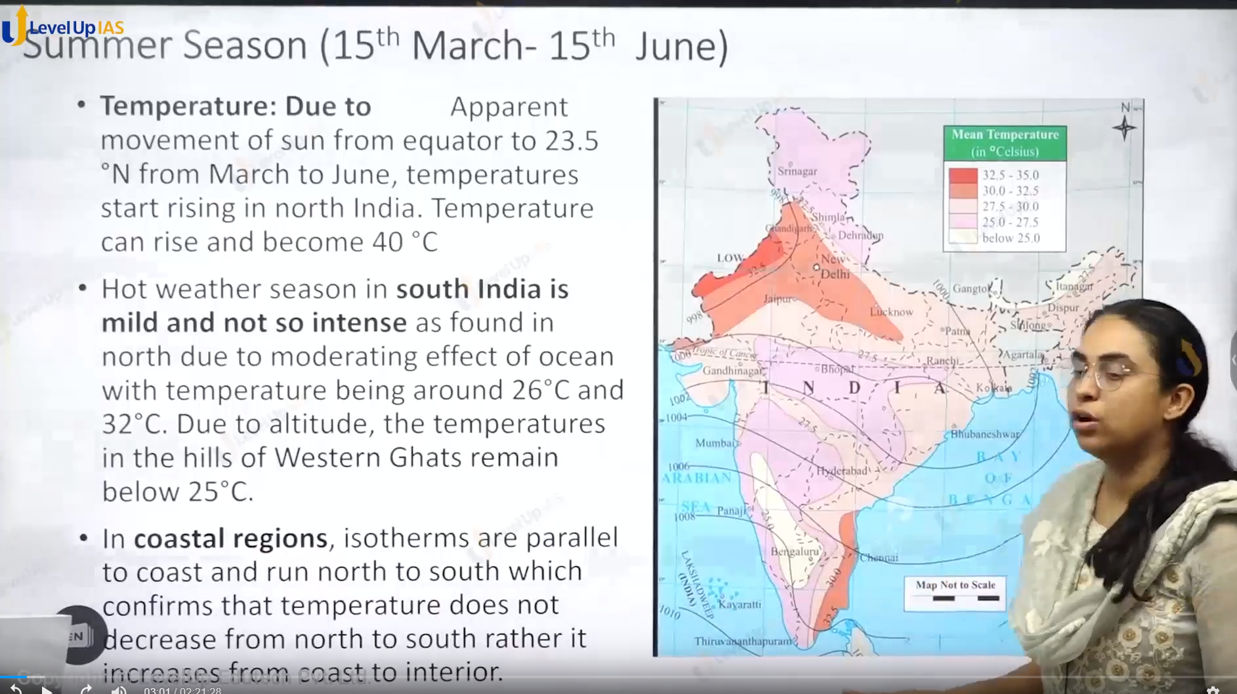

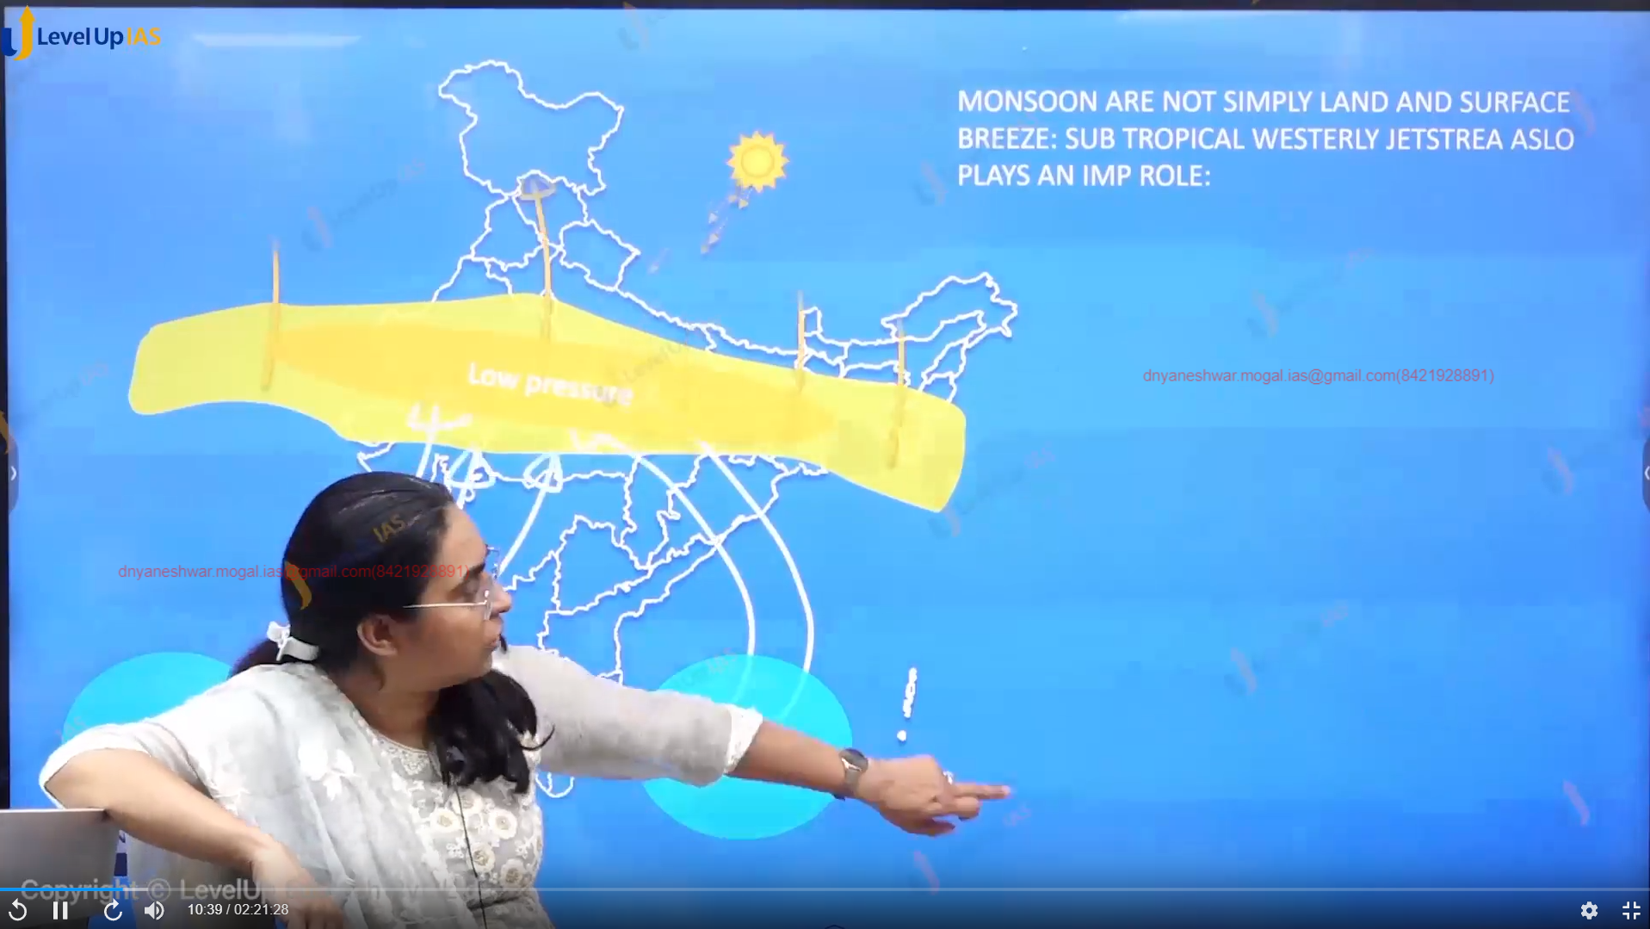

Monsoon Break:

1. It refers to period where there is no rainfall for few days. In the Monsoonal months.
2. The reasons for break in the monsoon are:
   1. Monsoon winds moving parrel to coastline not entering the Indian Peninsula.
   2. Reestablishment of sub-tropical westerlies jet Steam south of Tebet.

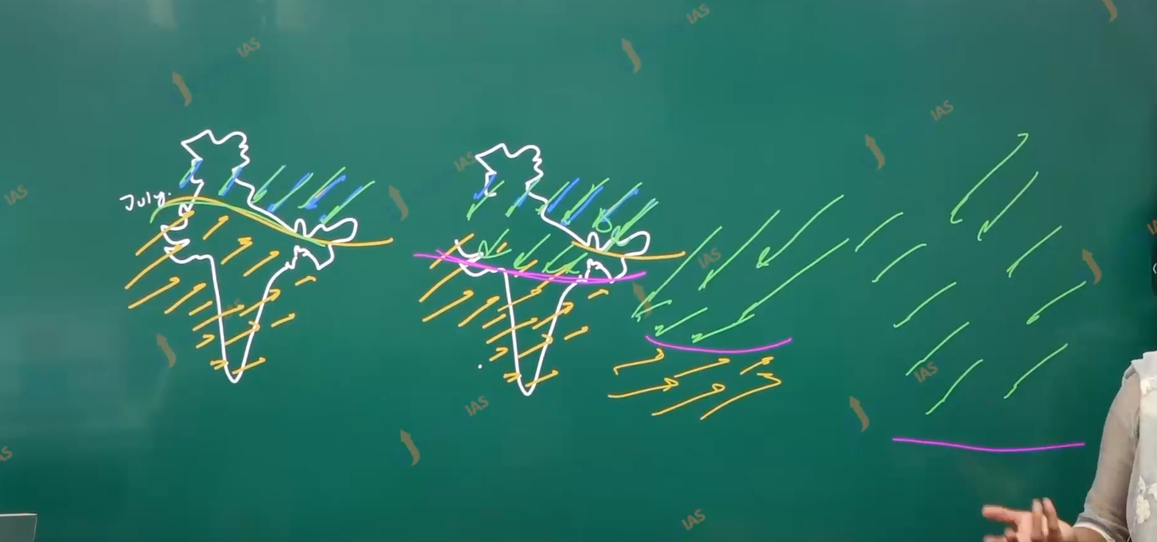

Withdrawal of Monsoon:

1. Withdrawal of monsoon starts with apparent shift of the sun. that is movement of sun from the tropical cancer to equator to tropic of Capricorn.
2. Due to shift of ITCZ the southwest monsoon winds begin to retreat. And space is taken up by the northeast monsoon winds.
3. In this season the retreat of monsoon is rapid in comparison to progress of winds.
4. The Season has October heat as the sky are clear and day temperatures is high, and land is still moist this leads high temperatures and high humidity and weather become quite oppressive
5. This season is accompanied by a tropical cyclone (Bay of Bengal). It brings rainfall on the southwest coast.

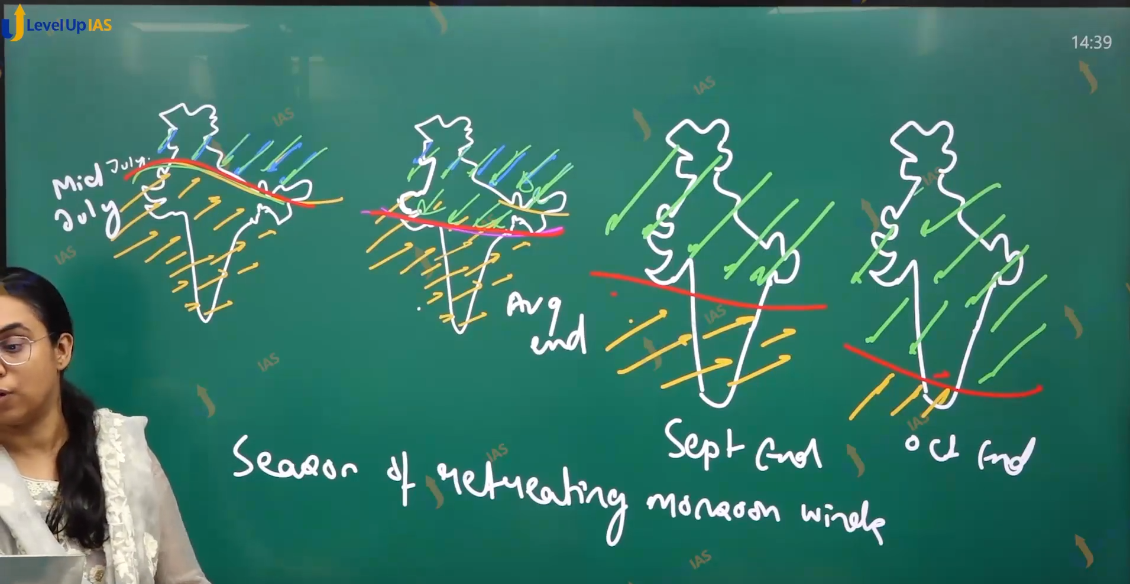

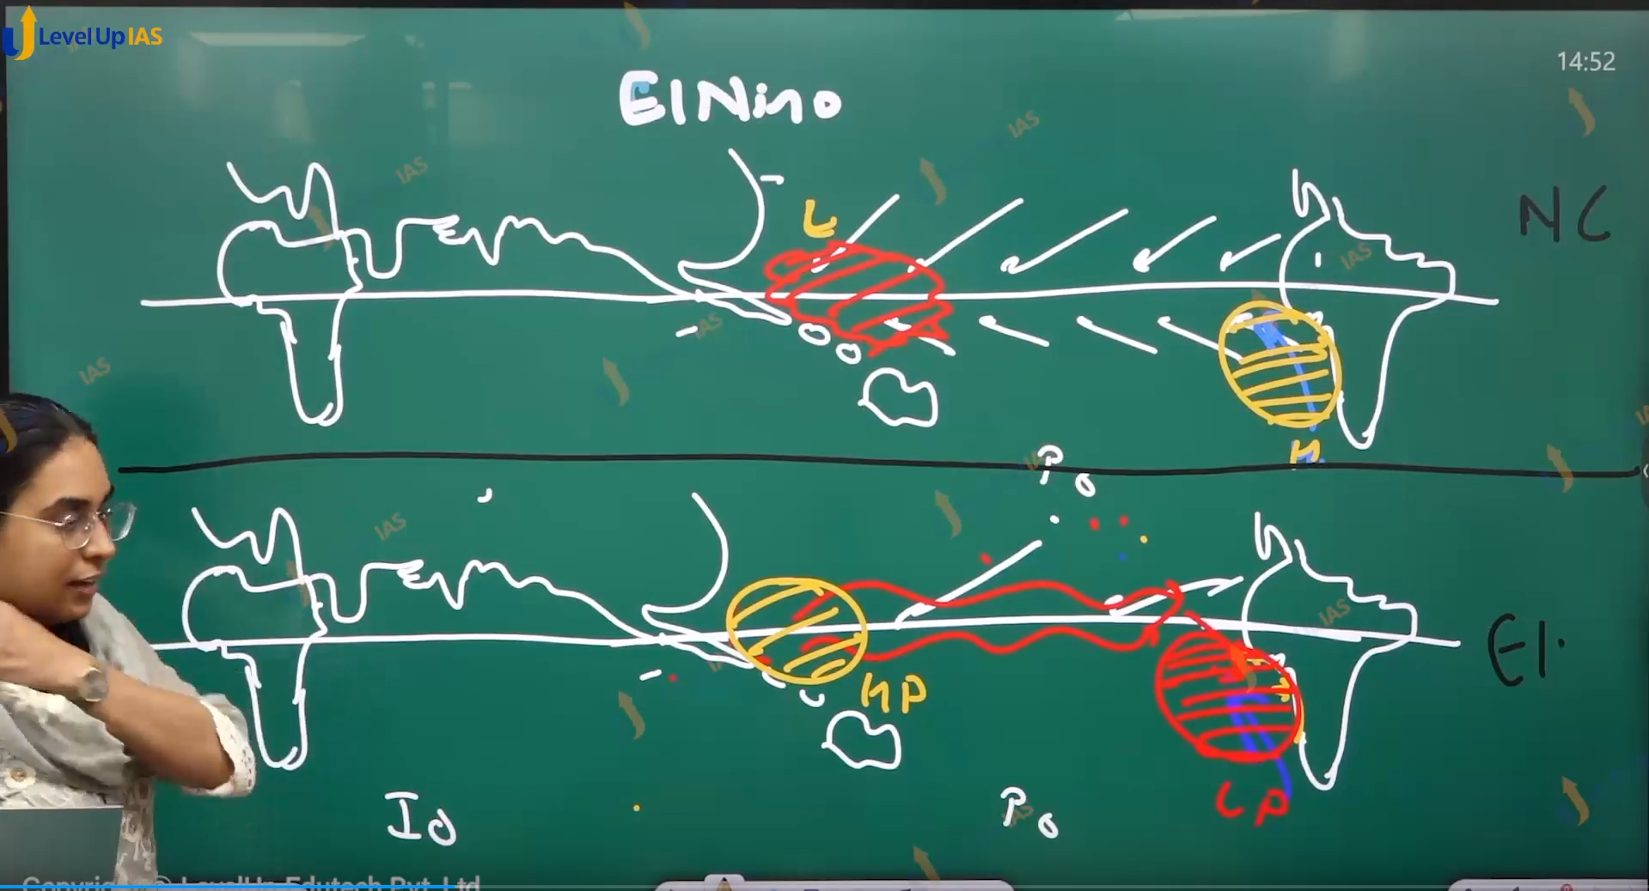

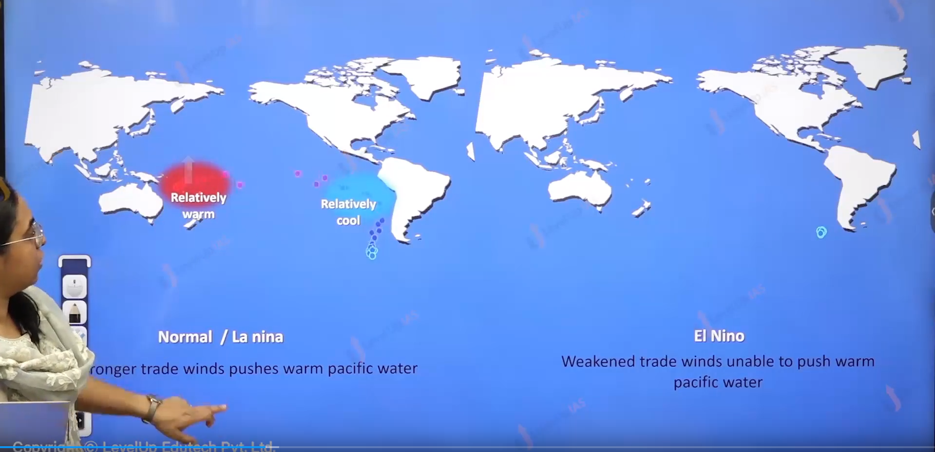

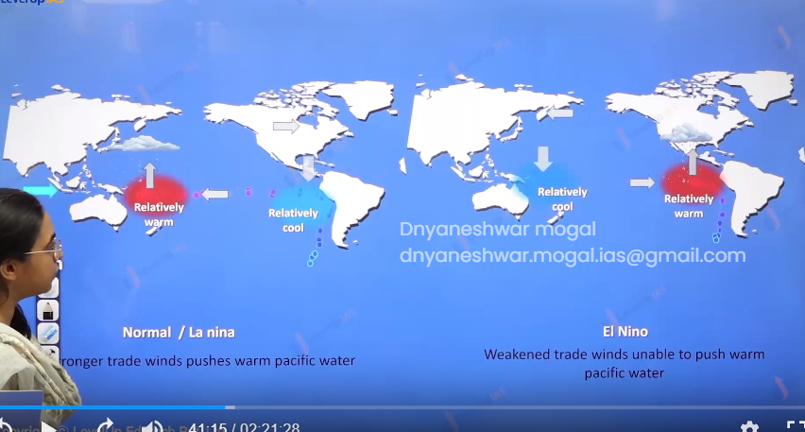

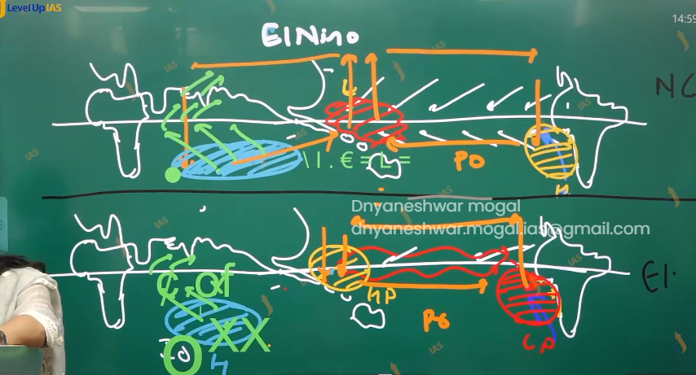

El Nino and Indian Monsoon:

1. Elso refers to flipflop variation of the pressure conditions. In the southern Pacific Ocean. During El Nino there is high pressure conditions along in Australia while there is low pressure conditions at the Peru. Thus, the walker cell such that air rises at Peru and sinks in Australia. This high pressure at the Australia counter acts the Mascarene high pressure.
2. Therefore, the weakening of macruran high pressure. Thus, weaking the southeast winds interns southwest Monsoon.
3. This leads to drought and dry conditions in India.
4. During La Nina year there is very strong high pressure at Peru. And very strong low pressure in Australia thus walker cell such that there is raising air at the Australia while there is sinking air at Peru (walker cell in the Pacific Ocean)
5. There is one more branch of walker cell in the India ocean the raising air in Australia sinks at Mascarene high this feather strengths Mascarene high leading to powerful southeast monsoon winds thus powerful southwest monsoon winds.

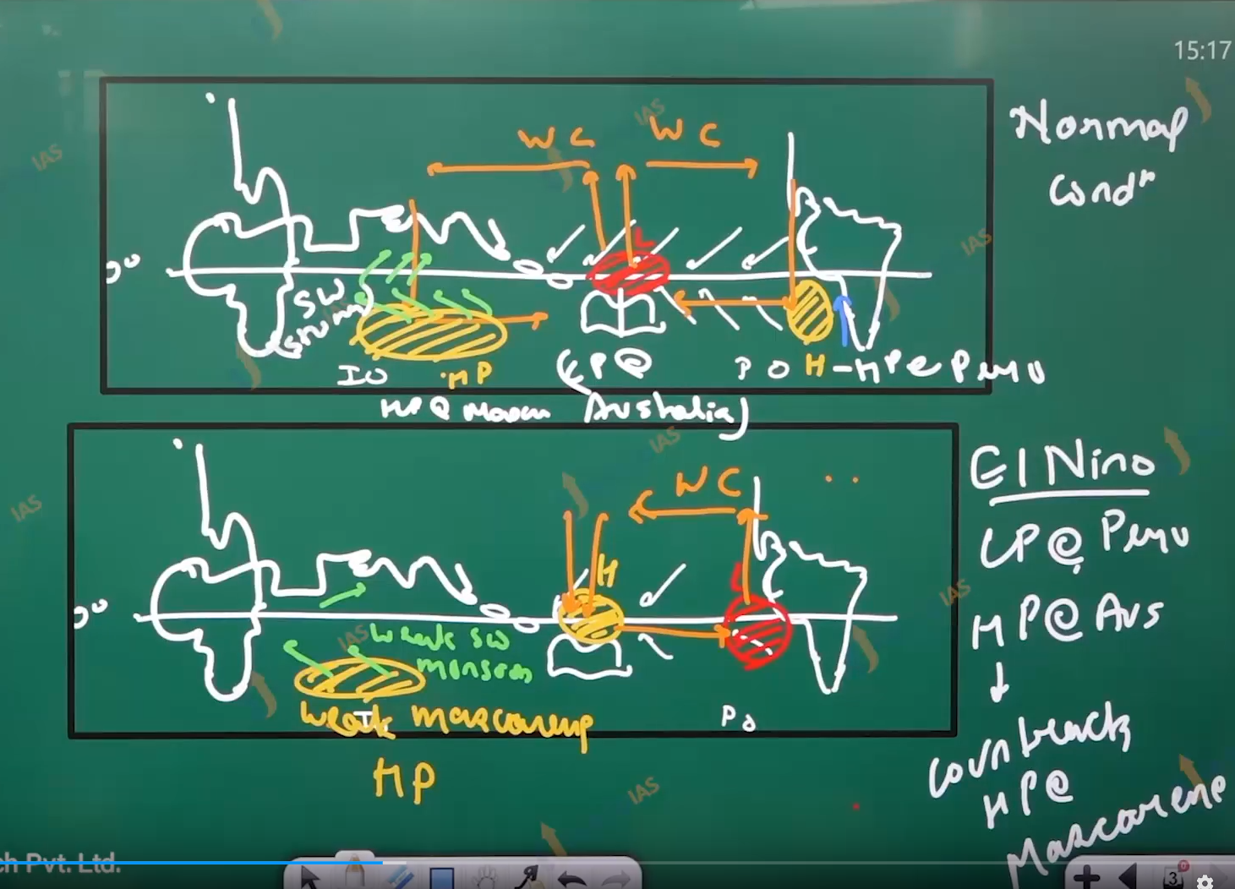

India Monsoon is affected by:

1. Low pressure in Tibet.
2. High pressure at Mascarene
3. The position of ITCZ
4. The Position the Sub-tropical westerlies jet Stream.
5. The Intensity of Tropical Easterlies JetStream.
6. Enso
7. Indian ocean Dipole
8. MJO AND PDO (Madden Jollain oscillation pacidial Decidual oscillation)
9. El Nino Modoki.
10. Tripal dip La Nina’s

Indian Ocean Dipole:

1. Due to difference in the configuration of Arabian sea and Bay of Bengal, there size, relative mixing water two sea, do not have same thermal condition.
2. Bay of Bengal is relatively warmer while Arabian sea is relatively cooler in General.
3. However, the conditions can reverse and therefore the pressure conditions can reverse thus they can form the dipole or local Circulation Cell.
4. Positive IOD refers to conditions where western Indian ocean along Arabian Sea southwest Asia has warmer condition while Negative IOD refers to conditions where eastern Indian ocean has warmer conditions.

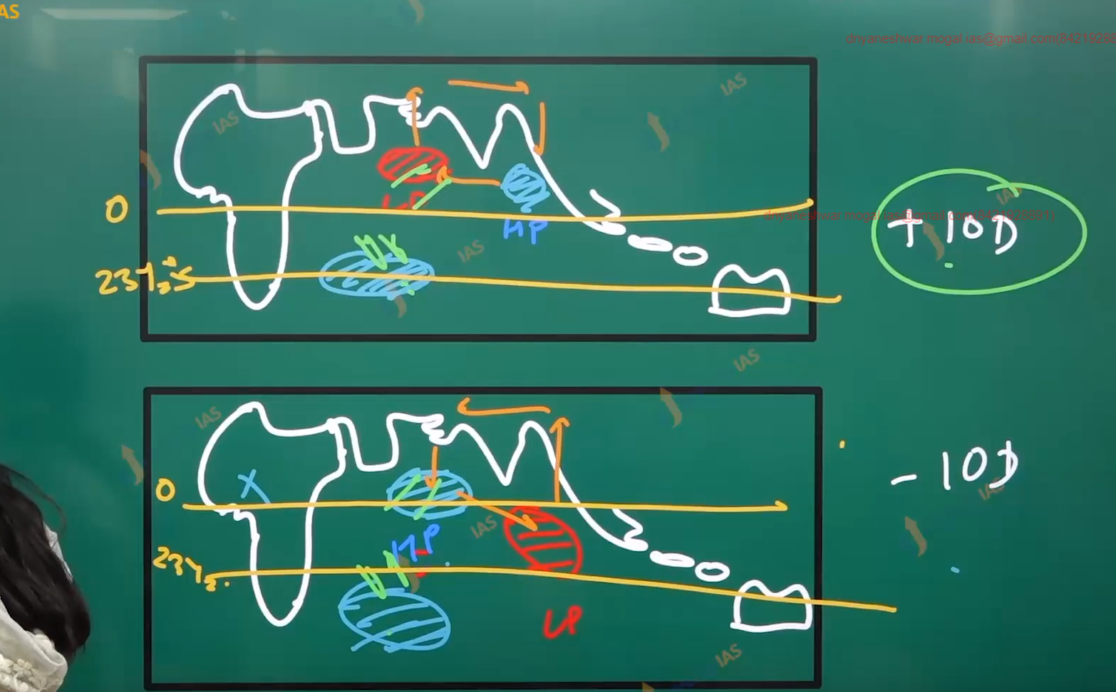

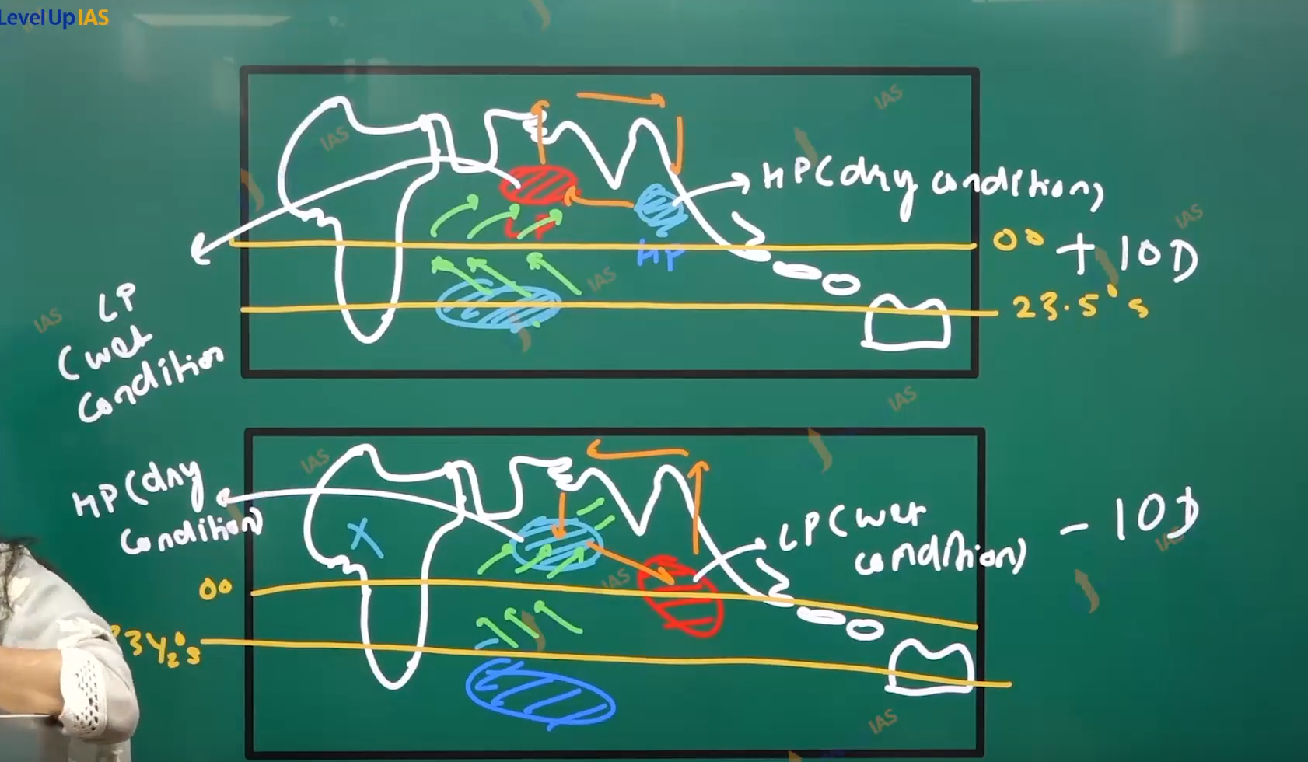

 

The Rainfall Pattern of India:

1. The average rainfall of India is 115 to 218 cm in year.
2. India is wet country. India has temporal variation 80% of rainfall received in the Monson season whereas summer and winter are relatively dry
3. India also has special variation in the region of Andaman Nicobar Lakshadweep western side of western ghat, North ester reason the rainfall is greater than 250 cm. there are places which have rainfall less that 60 cm the places are dry and semi added , Rajasthan Ladakh , and peninsular Interior.
4. The area of moderate rainfall rest of country.

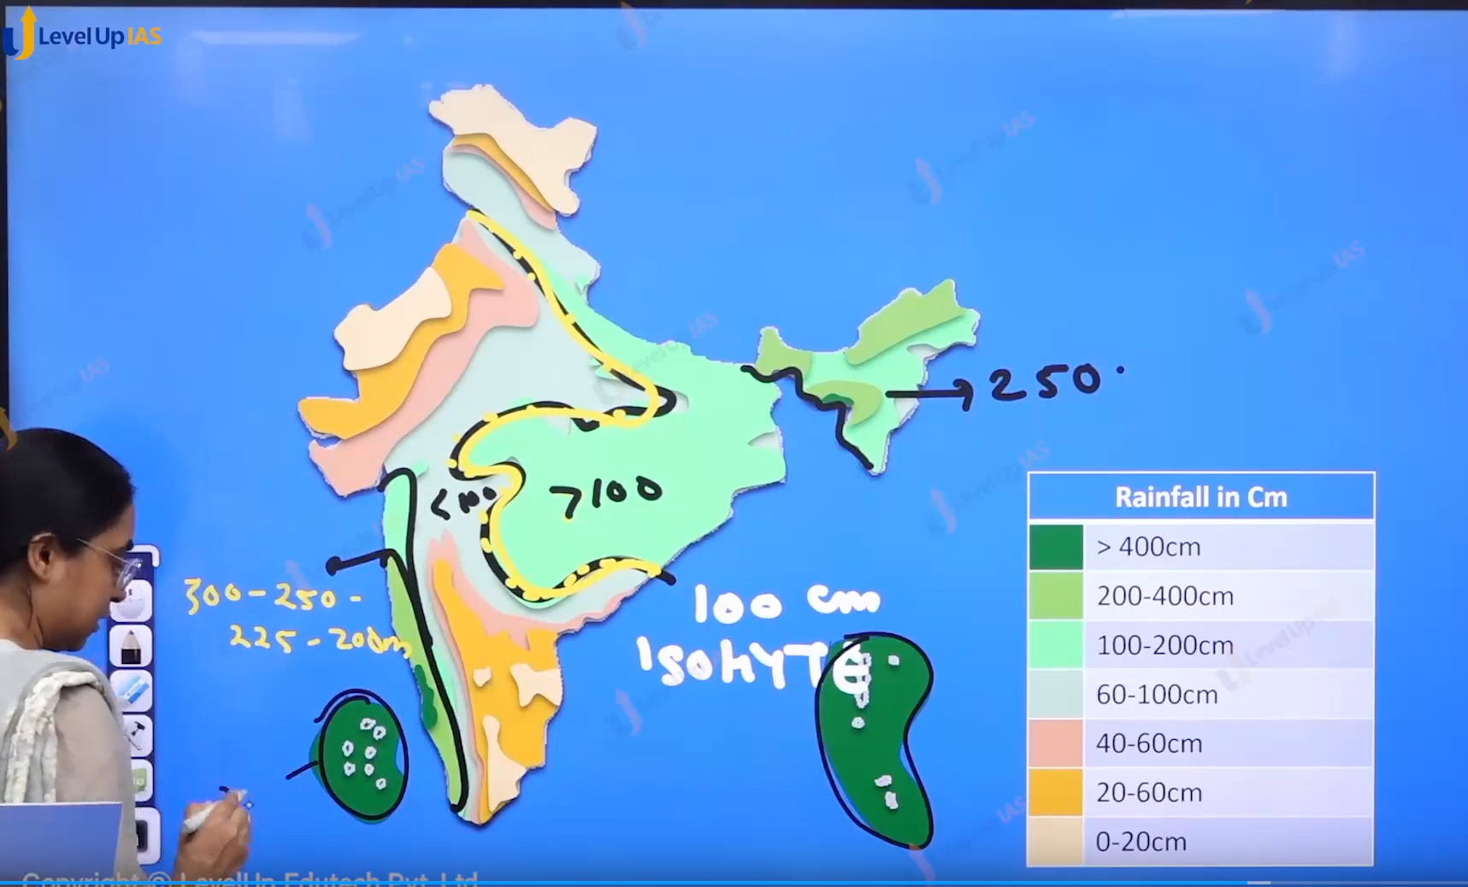

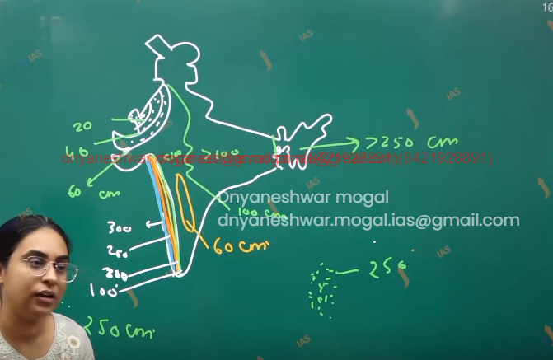

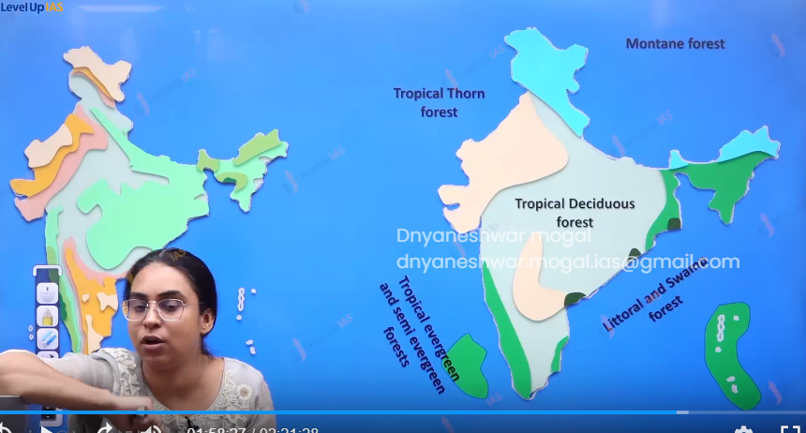

1. Indian precipitation Map coincides with the vegetation map tropical evergreen forest is found in the region of western side of western Ghat Andaman Nicobar Lakshadweep Northeastern region thorny forest found in the Rajasthan Ladakh and peninsular interior.
2. Mangrove forest is found in along the coast of India Andaman Nicobar Islands Lakshadweep. Tropical decidual forests are found in the major parts of country, mountains forest are along the Himalayas and western ghat.



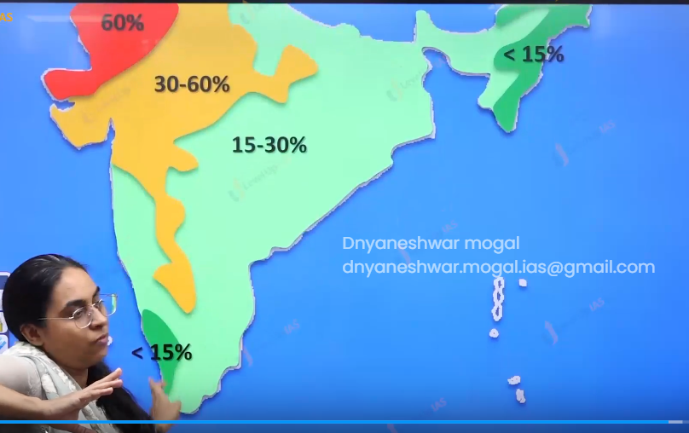

Variability of India Monsoon:

1. Indian monsoon is erratic. And suffer from very high variability it seen that in the places with heavy rainfall the variability of Monsoon is very less ex western Ghat Northeast India and Andaman and Nicobar Lakshadweep the variability is less that 15% and places which have less heavy rainfall they suffer from high monsoon variability the variability is has as high as 60 %.

